FCC PILGRIM PULSE
April 2022
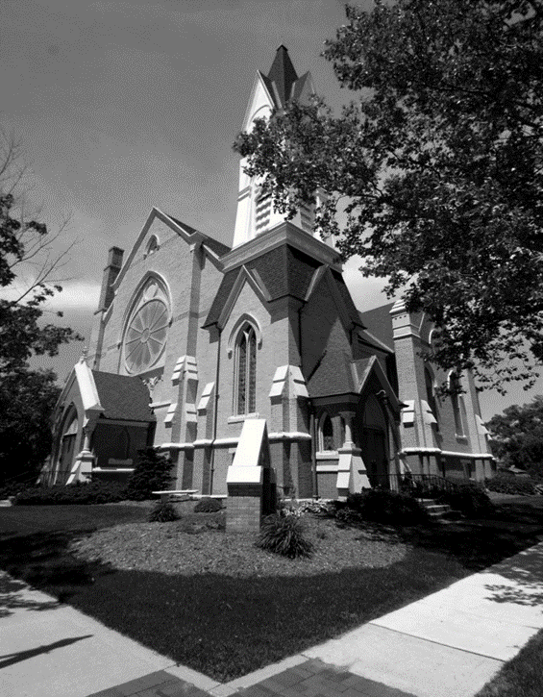

A Message from our Pastor…”Love Lived Out”
In 1 John 3:16-18 it says, “¹⁶This is how we know what love is: Jesus Christ laid down his life for us. And we ought to lay down our lives for our brothers and sisters. ¹⁷If anyone has material possessions and sees a brother or sister in need but has no pity on them, how can the love of God be in that person? ¹⁸Dear children, let us not love with words or speech but with actions and in truth. “
John was writing to assure the fellowship of believers that they are to operate with the example of Jesus in mind. During this time, there was much confusion in the church. False teachers were teaching that knowledge was the way to salvation and that Jesus was not the Son of God. Those early believers were struggling with identifying the patterns and lifestyle of a true believer. John is pointing them to Jesus as one they should model their lives after.
John reminds them that Jesus gave himself for everyone’s sake. His selfless sacrifice made it possible for us to receive salvation. It was this selfless and sacrificial love that John is bringing to light as the benchmark for all believers to model. If we are truly model Christ, then we should respond to the world around us in the same way Jesus responded to the world. Service and sacrifice should be the trademark of the authentic Christian.
As a Christian we are to concern ourselves more with serving and helping those around us, then taking care of our own needs. This is why he wrote “How does God’s love abide in anyone who has the world’s goods and sees a brother or sister in need and yet refuses to help?” The natural response of a Christian should be an outpouring of love for others that reflects the inward love felt from God. Those who have been blessed should respond by blessing others. John is reminding them that through their belief in and understanding of Jesus Christ, they should deepen their commitment to the ministry he modeled. This commitment comes at a price. The price is the same price as Jesus modeled, selfless sacrifice. This does not mean that we are all going to die for others, but it does mean we are to die to our own self-centered ways and be more concerned about the needs of others. There is a saying that goes “It easier to say we would die for someone then to truly live for them.” The outpouring of love to others is the trademark of a true Christian.
At the end of the day talk is cheap. If we are truly committed to an authentic Christian life, then the way we act and how we serve others will define us. Do our actions reflect our hearts? Do we respond with love and commitment in all that we do?
When we are fully committed to living a life in the fullness of God’s love then all we do becomes a “get to” opportunity, not a “have to” burden. When we are fully engaged in our Christian faith then we will have a desire to pray, a desire to worship at church with our family of faith, a desire to give generously to the ministries of the church, a desire to serve the world around you and a desire to share your faith story with others. If you are looking for a peace, joy, satisfaction, contentment, and the opportunity to make a difference in this world, then fill yourself with God’s love and commit to a life in the service of other with an attitude of I “get to” not I “have to”. Showing God’s love to others through how we live our lives, will help transform the world into a place where people can find peace. I pray that God’s blessing will continue to be on us as we serve Him each and every day.
Easter Blessings to all!
Pastor Ed Milam

If you wish to have your name or your loved one to be placed on our prayer list, please contact the church office. *Please remember you must have permission to do so. Thank you!
IN OUR PRAYERS
OUR MILITARY: Matthew Crittenden, Jordan Varney, Paul Lepley, TJ Curry, Joshua Roose,
Stephanie Roose, Melissa Staffen, Rick Grimes, Joe Suchowolec, Griffin Gloden, and Kyle Durdle.
Ongoing prayers for:
Lucas Hopkins  Rob Sansom  Trudy Petersen | Jerry McPherson  Gloria McPherson  Jeanne Beauvais | Dr. Joseph Mejia  Ken & Kathy Reed  Debbie Graham | Deb Kazmierczak  John Koppenol  Deb Kazmierczak | James Griffith, Jr.  Brian Tiffany
FCC Family At Care Facilities:
Lois Hazelwood  Bette Houle  Corla Morgan  Jelane Hamper  Barb Hoy  Mable Tate  Pat Toth |  | -at Hathaway Hills Assisted Living Room #31  -at The Brook Assisted Living, Cedar Springs  -at SHUM RNC, Room #103  -at Green Acres, Room #206  -at Canal View Houghton County Medical Facility  -at United Rehab and Nursing, Room #108  -at Hathaway Hills Assisted Living, Room #15
Members, Family and Friends:
Robin Hartway  Jerry Haverdink  Chris & Loraine |  | Friend to many and (former) Preschool Grandma  Father of Cindy Hanson  Friends of Jane Truesdell
Congratulations!
- To Tevin & Haley Tipton on the birth of their daughter, Hadley Rae. She was born March 17th and was welcomed by her brother Weston, Grandma Chris Tipton, and Great Grandma Chris Hubbard.
*Thank you to all for your Prayers! Please feel free to send a card to anyone listed above.

Pastoral Contact Info:
If you are in need of prayers or other assistance, please feel free to email Pastor Ed at pastor.edfccog@gmail.com.

Trustees of the Month: Judy Swartz and Scott Horn
Deacon of the Month: Jerry McPherson
BOARD MEETINGS:
Deacons: Tuesday, April 12th at 6:30pm
Trustees: Monday, April 25th at 6:30pm

Pastoral News
NEW THIS YEAR!
~ FCC News And Announcements ~
We are excited to have received our new member, Kathy Jeppesen! We welcome her to our faith family in March. She transferred her membership from the Sheridan Congregational Church.
- If you or someone you know is interested in joining our faith family, we will be holding another member class in the Fall. Watch your newsletter and bulletins for the new date! Contact the church office or Pastor Ed for more info if you are feeling led to join this community of faith by becoming a member.
- We are also looking to host a Baptism Sunday for any and all ages! If you have a little one or (you) would yourself, like to be baptized, please contact Pastor Ed, or the church office.
Church Office News
The church office hours are Mon. through Thurs. from 9:00-3:30 with a break from 2:00-2:30pm. Please call ahead if you need assistance.
- Please update your contact info (new address, email or phone number) to receive any church mailings, with the church office.
FCC Council News
Your Church Council is pleased (and relieved) to report that we’ll be presenting a proposal for some final revisions to the Bylaws in April, with the vote planned for Annual Meeting. This Bylaws review has been a much longer and more complicated process than we first expected, having begun in 2018. But at long last, the end is in sight! Announcements will begin on April 24, and copies of the proposal will be available as of that date.
- Annual Meeting: we are looking at either May 15th or May 22nd. For either date, we’ll have the meeting after church. A potluck is being discussed as well, either before or after the meeting. So, pencil these dates in; an announcement with definite plans will be made soon!
- FCC Leaders: If you have not done so, please submit your annual report for the 2021 FY to the office ASAP!
Celebrations
Parish Nurse News
Happy Birthday! To Jack Corner (4/7), Lizzy Emerson (4/7), Bonnie Braman (4/8), Rosel Eagles (4/8), Duane Putnam (4/10), Joe Suchowolec (4/17), Gloria McPherson (4/23), and Marilyn Jones (4/25). Happy Anniversary! To Bryan & Angela Garvey (4/28).
Our Nurse is available Mon. and Tues. from 8-4, and on Thurs. from 8-12. If you have medical questions or concerns, please call Patrice at 616-894-7288.
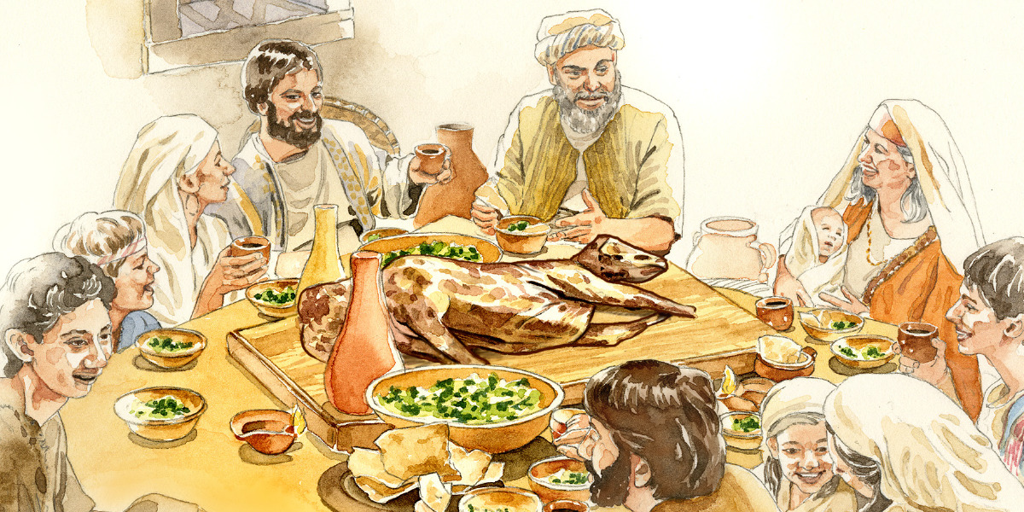
- Pastor Ed is conducting a PASSOVER MEAL for Maundy Thursday, April 14 at 6pm. To help prepare, PLEASE SIGN UP ON THE BULLETIN BOARD OR CALL THE OFFICE TO RESERVE YOUR SPACE and please let us know how many are attending with you!
- Women’s Fellowship needs your help to provide either a crockpot of beef stew or a dozen biscuits. The meal is simple as it was in Jesus’ time. If you can provide food, please contact Chris Hubbard at 754-7464 or Fran Gibbs at 754-7714 and leave a message. *Dinner will be followed by a short program in Fellowship Hall.
Church Renovation News
Please “pardon our dust,” as we continue to update and clean up the church! We have new exciting things that will be happening over the next several months to help update and improve our church! Thank you for your continued support and patience during this time!
Women’s Fellowship News
- Spring Rummage Sale: Start cleaning out your closets now for the SPRING RUMMAGE SALE, on FRIDAY, MAY 6. You can drop off your items beginning Monday, May 2. Set up is Thursday, May 5. WE NEED WORKERS!
- If you can take a shift on either of these days, please see Rosel Eagles or call her at 754-8618.
- Our next meeting is after church on April 26 at 1pm to plan our rummage sale.
PF Youth News
The NAPF and HOPE 2022 Conference will be in Wichta, Kansas at Newman University on June 25-29. The registration fee is $425. *Registration is now open! Any questions, email napfhope@gmail.com. *Contact Claude Johnson if you would like more info on joining the youth group or upcoming missions, at claudej2002us@yahoo.com.

Christian Ed News
Deacons News
- Sunday School: The spring curriculum begins with Palm Sunday lessons. There is no Sunday School on April 3rd for Communion and on Easter so that our families can worship together. We will finish up this school year’s lessons on Sunday School on May 15. Children in grades Pre-k to 6th grade can attend Sunday School and are welcome to visit anytime! Our teachers are prepared for extra students!
- Children’s Sermon: are being scheduled into April and beyond. Please limit your Children’s Sermon to no more than 4 minutes. If you have something to share with our youth, please see Fran Gibbs to get on the schedule. You can call Fran at (616) 232-1131 or email her at gibbsf7714@gmail.com.
- Vacation Bible School is being held at St. Paul Lutheran Church again this year. More information will be coming out.
Preschool News
The children are having their annual Easter Egg hunt this month with a visit from the Easter Bunny!
• A special thanks to those who ordered popcorn to help support our Preschool Program! Orders will be available for pick-up after April 6th. Call the office to schedule pick-up or you can pick up your order Sunday, April 10th.
• Registration packets for fall classes will be available April 11th. If you or someone you know would like more information on our to a wonderful, fun & loving Christian based school, contact the office.
Music Committee News
Special Music line-up for April:
- April 3 – performance by Deb Dieckman.
- April 10 – a performance by the Praise Choir.
- April 17 – performance Chancel Choir.
- April 24 – performance by the Preschoolers.
- If you would like to sing with the choir, or provide special music, contact Deb Dieckman or the church office.
Children’s Praise Choir
- We are still pursuing any interested people to direct choir, accompany choir. This is a paid position! See Fran Gibbs for more information.
Our Practices are every Thursday from 4-5pm and we invite children of all ages to join us as we sing, dance, and enjoy games & snacks! Our next performance will be April 10th, on Palm Sunday Service.
- We are asking for donations of individually wraped treats for the children. If you would like to donate treats, please drop them off to Candy. Thank you!
- The Board of Deacons will meet on April 12 at 6:30 in the Conference Room upstairs. Planning for the Easter service and beyond will be discussed.
- Join us for Coffee Service on April 10th. Beverages will be provided. If anyone wishes to contribute some cookies to share, feel free to bring some in.
- Easter Flowers: Thank you to everyone for purchasing a lily in honor or in memory of a loved one, and for your continued support of our DDF! Please feel free to pick up your plant after the Easter service on the 17th or anytime during the week after Easter. Thank you!
FCC Honorees
- 2021 GPS Performing Arts Hall of Fame Inductees: Peter & Cindy Hanson have been active in the Greenville Community for decades. Peter, a 1980 graduate of Ionia High School and Cindy, a 1981 graduate of Unity Christian High School met at Ferris State University in the marching band. Peter played trombone, and Cindy was in the flag corps. She also played clarinet on a music scholarship in the FSU concert band. Some of their best memories are from their college band experience, including playing a halftime shows at Detroit Lions football games! Peter & Cindy have been indispensable to the GHS music program. Peter has driven the band and orchestra trailer to and from every “on the road” performance since 1999. This includes four band trips to Disney World, a jazz band trip to St. Louis and countless statewide marching band, jazz and band and orchestra festivals. Cindy used her many years in Scouting helping on each trip as a chaperone and first aid go-to. As if that were not enough, Peter & Cindy also ran the concessions stand at home football games at Black Field from 1999-2008! Cindy also played organ for the Congregational Church and in 2009 Peter & Cindy were award the GPS Elmer Russell “School Bell Award”. Peter says, “he has always loved music and the character it builds in those young budding musicians”. Peter & Cindy state that “Greenville is blessed with a wonderful fine arts program and it has been a joy to watch so many young people grow into responsible adults!”
- GPS Athletic Volenteer Retirement: Congratulations to Jack Corner who was recognized and awarded by the Greenville Athletics Department for the 20+ years of service and volunteerism with many of the High School Sports. He has helped with track, football, wrestling, baseball, and many other sports. He will be greatly missed!
~ April 2022 ~
Sun | Mon | Tue | Wed | Thu | Fri | Sat
 |  |  |  |  | 1 | 2  Spring Break April 1-4
3 Communion  10:30 Worship  Special Music –  TBA  Spring Break  3p Venture | 4  (All) School Resumes | 5  5:30 GS | 6  10a PURLS  *Preschool Fundraiser is delivered | 7  11a GAMA  4p Praise Choir  4:30 Scouts (all)  7:30 AA | 8 | 9
10 Palm  Sunday  10:30 Worship  Special Music –  TBA | 11 | 12  5 Venture Crew  5:30 GS  6:30 Preschool  6:30 Deacons | 13  10a PURLS  4p Girl Scouts | 14  Maundy Thursday  4p Praise Choir  4:30 Scouts (all)  6p Service  7:30 AA | 15  Good Friday  *Service at Calvary Baptist | 16  Holy Saturday
17 Easter  Sunday  10:30 Worship  Special Music –  TBA  3p Venture | 18 | 19  5:30 GS | 20  10a PURLS  4p Girl Scouts | 21  4p Praise Choir  4:30 Scouts (all)  7:30 AA | 22 | 23
24  10:30 Worship  Special Music –  TBA | 25  6:30 Trustees | 26  1p WF Mtg.  5:30 GS | 27  10a PURLS  4p Girl Scouts | 28  4p Praise Choir  4:30 Scouts (all)  7:30 AA | 29 | 30
Calendar Notes:

~ May 2022 ~
Sun | Mon | Tue | Wed | Thu | Fri | Sat
1 Communion  10:30 Worship  Special Music –  TBA  3p Venture | 2 | 3  5:30 GS | 4  10a PURLS | 5  11a GAMA  4p Praise Choir  4:30 Scouts (all)  7:30 AA | 6  8a WF Rummage Sale | 7
8  Mother’s Day  10:30 Worship  Special Music –  TBA | 9 | 10  5:30 GS | 11  10a PURLS | 12  4p Praise Choir  4:30 Scouts (all)  7:30 AA | 13 | 14
15 Children’s  Sunday & Teacher Recoginition  10:30 Worship  Special Music –  TBA  3p Venture | 16 | 17  5:30 GS | 18  10a PURLS | 19  4p Praise Choir  4:30 Scouts (all)  7:30 AA | 20 | 21
22 Graduation  Sunday  10:30 Worship  Special Music –  TBA | 23  6:30 Trustees | 24  5:30 GS | 25  10a PURLS | 26  Ascension of the Lord  4p Praise Choir  4:30 Scouts (all)  7:30 AA | 27 | 28
29  10:30 Worship  Special Music –  TBA | 30  ~office closed~ | 31
Calendar Notes:

Easter Flowers ~ 2022
The Easter flowers adorning our chancel this Easter were placed by the following families and friends.
Donor Placed for….
Patty Barber In Memory of Ted Barber, Kenneth & Ethel Wilson, and Dean & Edith Wiesen
Bruce & Sue Beauvais In Memory of Carl & Evelyn Berg and Robert & Ruth Beauvais
In Honor of Lyn Zilch and Jeanne Beauvais
Bart Brown In Memory of Marilyn Brown nee Fries and Prudence Bower Tower
Larry & Karen In Memory of Kevin Carbonelli, Elisa Nelson, Muriel Carbonelli, Guido Carbonelli,
Carbonelli Robert & Elizabeth Waldo, Doug Shaw, and John Stafford
Virginia Evans In Memory of Marvin Evans
Patrice Fulton-Peacock In Honor of Jess & Kyle, Jacque & Jason, Jake & Rose, Elise & Ellia Devitt,
and Eli & Grant Kuenzer
Don & Fran Gibbs In Memory of Phyllis & Bill Ham, and Don Gibbs, Sr.
In Honor of Shirley Gibbs, Our Children, & Our Grandchildren
Judy Graham In Memory of Dale Graham, Hubert & Bettye Graham, and Bob & Ann Snyder
Chris Hubbard In Memory of Russell Hubbard (husband), Sandy, Rose, Janet, Craig, Tim, and Brian
In Honor of my Children, Grandchildren and Great-grandchildren
Karen Hulbert In Memory of David Hulbert, Richard Canfield,
and Kathy Lee Cristofoli, my beautiful sister
Claude Johnson In Memory of My Parents, Grandparents, and Great-grandparents,
Clarence H. Johnson, and Gwendolyn C. Wagner (siblings)
In Honor of my children, grandchildren, & great-grandchildren, and
The Local, State & National PF
Marilyn & In Memory of Our Parents
Rev. Jerry Jones In Honor of Our Son & his family and Our Daughter & her family
Ron Kingsbury In Memory of Dixie Kingsbury, loving wife
In Honor of my daughters: Deb and Lisa
Michele Kocher In Memory of Lynn & Jaquelyn Kocher
In Honor of Women’s Fellowship, Andy, Nathan, Kyle, and Rylie
Jim & Pam Koski In Memory of Jim’s parents: Henry & Charlotte Koski
and Pam’s parents: Ray & Ardella Payton
Kurt & Suzy Kreeger In Memory of Roma Dart, Norma Nicholas
In Honor of our parents: Mary & Hal Kreeger and Bonnie & Bob Hoseth
Carol Magoon In Memory of Raymond Magoon (husband), Trudi, Chel, Nathan,
And Christina (children & grandchildren)
Gerald & Gloria In Memory of our Parents Burt & Julia McPherson, and Jay & Elouise Olsen
McPherson In Honor of Our Children, grandchildren and great-grandchildren
Pastor Ed & Jenny Milam In Memory of Charlie & Peggy Milam (Pastor Ed’s parents)
In Honor of Betty Pettit (Jenny’s mom) and Kristen, Sarah,
and Rachael Milam (Ed & Jenny’s girls)
Vivian Minard In Memory of Carrol Minard, loving husband
Don & Julie Momber In Memory of June Momber, Dalyn & Nancy Ling, and David Ling
In Honor of Our grandchildren: Christian, Reagan, Ada, and Logan
Darlene Petersen In Memory of Darwin (Buzz) Petersen, loving husband and Gary Petersen (son)
Duane Putnam In Memory of my mother Viola Putnam and Grandson Levi Putnam
Linda Stafford In Memory of John Stafford, Leslie Stafford, Vivian & Dale Stafford, Hazel & Bob O’Connor, Kitty Armel, Margie Scheid, Al Vining, & Jack Harris
In Honor of Marilyn & Jerry Jones and the Ian Macdonald family
Ken & Coleen Venema In Memory of Rex & Marion Braginton and Herman & Betty Venema
In Honor of Our Children and Grandchildren
Lynn & Bonnie In Memory of Joe & Ruth Wickerham and Waldo & Marguerite Fisher
Wickerham In Honor of Brent, Karen, Brett Wickerham, Denise Webb, Greta Schultz, Nicholas,
Blake, Colleen, and Holden Wickerham, and Our Lord and Savior & Church Family
Thank you and Happy Easter to All!

