FCC PILGRIM PULSE
June 2022
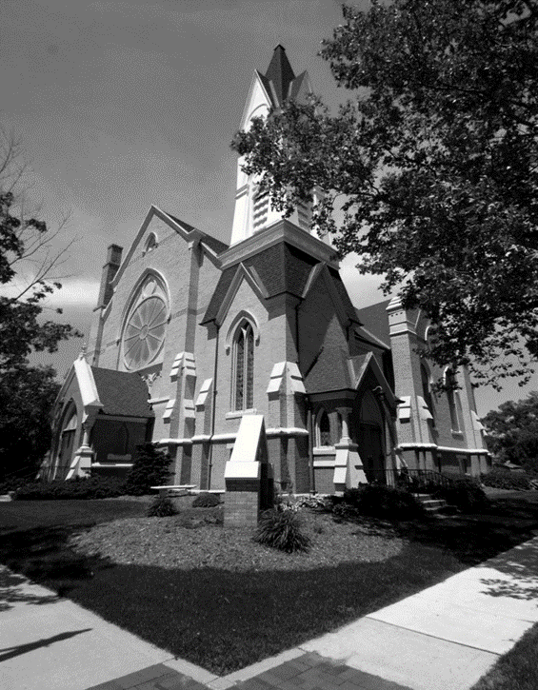

A Message from our Pastor…A Safe Place
We all desire a safe place to live our lives surrounded by people who truly care about us. We want to feel the safety and security of being part of a family that loves and encourages each other. It would be nice if there was a place where you could go where people love and respect you as a brother or sister. A place where your joys are their joys and your hurts are their hurts. A family that cares for each other through every phase of life. There is such a place and there is such a family. It is called your church.
Every Sunday people gather in churches everywhere. These communities of faith worship, sing, pray and serve God in a multitude of different ways. The early church modeled for us the mindset of a connected and caring church. Acts 2:42-47 say this “42 They devoted themselves to the apostles’ teaching and to fellowship, to the breaking of bread and to prayer. 43 Everyone was filled with awe at the many wonders and signs performed by the apostles. 44 All the believers were together and had everything in common. 45 They sold property and possessions to give to anyone who had need. 46 Every day they continued to meet together in the temple courts. They broke bread in their homes and ate together with glad and sincere hearts, 47 praising God and enjoying the favor of all the people. And the Lord added to their number daily those who were being saved.”
The church is a place where we gather together to live out our live as followers of Christ. We worship, celebrate and pray together as a group. We also eat, work and play together through the many phases of life. When I was a little kid, I remember going to church on Sunday mornings. We drove in from the county to a church in town about 30 minutes from our house. I was always so excited to see my “church” friends as I called them. We all went to different schools, but at church we were all one team. It was awesome. I still have great memories of making crafts to give parents, singing songs and memorizing scripture verses. It was also a place where I always felt safe. I had several church moms and grandmas. I felt amazing to be a part of that church family.
As I got older and there where many more distractions in life, I found myself drifting away from my church family. Life was taking over the top spot in my world and church had fallen to a lower priority. Then we had our first child and we knew we wanted her baptized and raised in the church. The desire to be reconnected with our church family was powerful. The church was the place we knew we needed to raise our family. It has been an amazing blessing to be part of a church family that surrounds you with care and support.
The church is also the place where we go when life on this earth has ended and those we love have gone on to glory. In our times of lose and pain our church family is there in a powerful way. The love and comfort that comes from one’s church family is amazing. I have witnessed church family loving on each other and helping each other in there time of grief. My church family has been there for me many times. There is a special bond between the members of this very special church family. I have many wonderful memories from my life from being part of the church family.
The church is that place where people from many different back grounds come together to worship together as brothers and sisters in Christ. We believe that our lives are connected though this very powerful bond. There is a song by the Gaither Vocal Band called “This is The Place”. If you get a minute, take a listen. My friend Suzy sent me this and it has a powerful message.
If you are looking for a safe place to live life, then give church a chance. There are several awesome congregations in this community. You are always welcome to join us here at the First Congregational Church of Greenville. There is a safe place to live life. God’s loving church is for everyone!
Blessings in Christ,
Pastor Ed Milam

If you wish to have your name or your loved one to be placed on our prayer list, please contact the church office. *Please remember you must have permission to do so. Thank you!

IN OUR PRAYERS
OUR MILITARY: Matthew Crittenden, Jordan Varney, Paul Lepley, TJ Curry, Joshua Roose,
Stephanie Roose, Melissa Staffen, Rick Grimes, Joe Suchowolec, Griffin Gloden, and Kyle Durdle.
Ongoing prayers for:
Lucas Hopkins  Rob Sansom  Trudy Petersen | Jerry McPherson  Gloria McPherson  Robin Hartway | Dr. Joseph Mejia  Ken & Kathy Reed  Debbie Graham | John Koppenol  Jerry Haverdink  Axton Stearns | James Griffith, Jr.  Brian Tiffany  Bonnie Braman
FCC Family At Care Facilities:
Lois Hazelwood  Bette Houle  Corla Morgan  Jelane Hamper  Barb Hoy  Mable Tate  Pat Toth  Doris Dieckman Marshall |  | -at Hathaway Hills Assisted Living Room #31  -at The Brook Assisted Living, Cedar Springs  -at SHUM RNC, Room #103  -at Green Acres, Room #206  -at Canal View Houghton County Medical Facility  -at United Rehab and Nursing, Room #108  -at Hathaway Hills Assisted Living, Room #15  -at Green Acres, Apt. #207
Members, Family and Friends:
Darlene Petersen  Mabel Tate |  | FCC Member and Friend to all  FCC Member and Friend to all
A Message of Thanks:
- “I want to thank my church Family for all their prayers and cards. Especially want to thank Patrice for her support during my illness and prayers for my daughter and her grandson Gavin. Your kindness means a lot to me.” ~ Darlene Petersen.
*Thank you to all for your Prayers! Please feel free to send a card to anyone listed above.

Pastoral Contact Info:
If you are in need of prayers or other assistance, please feel free to email Pastor Ed at pastor.edfccog@gmail.com.

Trustees of the Month: Duane Putnam and Larry Snow
Deacon of the Month: Fran Gibbs
BOARD MEETINGS:
Deacons: Tuesday, June 14th at 6:30pm
Trustees: Monday, June 27th at 6:30pm

Pastoral News
Women’s Fellowship News
~ FCC News And Announcements ~
- Pastor Ed is currently holding confirmation classes for youth in grades 8 and older. If you or someone you know would like to attend these classes or more information, please contact Pastor Ed or the church office. Thank you!
- Member Class: If you or someone you know is interested in joining our faith family, we will be holding another member class in the Fall. Contact the church office or Pastor Ed for more info if you are feeling led to join this community of faith by becoming a member.
Church Office News
The church office hours are Mon. through Thurs. from 9:00-3:30 with a break from 2:00-2:30pm. Please call ahead if you need assistance.
- Please update your contact info (new address, email or phone number) to receive any church mailings, with the church office.
Celebrations
• Happy Birthday! To Kathy Reed (6/6), Steve Roose (6/9), Rose Riddle (6/11), Morgan M. Venema (6/15), Marian Griffith (6/17), Janet Tower (6/20), Corey Norman (6/21), Sophia Norman (6/23), and Dawson Weber (6/25).
- Happy Anniversary! To Steve & Diane Roose (6/11), Paul & Kris Jager (6/17), Ken & Kathy Reed (6/17), Duane & Anita Putnam (6/19), Janet & Cap Tower (6/20), Pastor Ed & Jenny Milam (6/20), Jim & Patti Ritzema (6/28), Kirk & Celeste Faber (6/29), and Ken & Coleen Venema (6/29).
- Card Party! Bette Houle is celebrating her 100th birthday and we will, too. A carpool will head out to The Brook in Cedar Springs on Friday, July 1, at 12:30 to celebrate with her and her church family. Be at the church by 12:15. Light refreshments will be served in a shaded outdoor setting with tables and chairs provided by her care facility. No gifts but don’t forget to bring a card to church by June 26 so we can deliver them on July 1! If you would like a ride or are willing to drive, please call Chris Hubbard at 754-7464.
Parish Nurse News
Our Nurse is available Mon. and Tues. from 8-4, and on Thurs. from 8-12. If you have medical questions or concerns, please call Patrice at 616-894-7288.
- Second COVID booster vaccines are available for anyone 50 years old and older and also for immunocompromised people.
- COVID booster vaccines are now also available for kids 5-11 years old who had their primary series at least 5 months ago.
- Spring Rummage Sale: we thank all of our workers who helped set-up, work the day of the sale, and box up items on Friday. We also thank everyone who donated their gently used items to help support our event. We raise over $700 dollars!
- We hosted the Birthday Luncheon after the Annual Meeting on May 22nd to honor those 80 and above! What a fun time of fellowship and food! Thank you to the many who made delicious food and stayed for this event! If you are turning 80 in 2023, please contact the church office or Chris Hubbard, as we would like to honor you at our next celebration
- FCC Women’s Fellowship is hosting a card shower for Bette Houle who turns 100 on July 4th! Please bring your cards to the office or at church from now until June 26th to send her wishes on her big day!
Christian Ed NEws
- Sunday School wrapped up on May 15th with honoring our teachers, awarding Bibles to First Graders, and enjoying the Praise Choir’s last performance until Fall. St. Paul Lutheran Church on M91 south of Greenville will be hosting Vacation Bible School this summer.
- Children’s Sermons will be given by Pastor Ed on summer Sundays starting June 12.
- Mark your calendars for September 11 for Sunday School to resume.
- Vacation Bible School: VBS will held at St. Paul’s Lutheran Church (south on 91 out across from the airport). It will be on July 26, 27, and 28. Dinner will be served at 5:30 and classes will be from 6:00-8:00pm. If you have any questions, please contact Fran Gibbs.
Preschool News
- The children will graduate on June 5th at 1:00pm here at church and the Annual End-of-year picnic at Ms. Candy’s farm will be on Monday the 6th.
• Registration packets for fall classes are still available! If you or someone you know would like more information on our wonderful, fun & loving, Christian based school, contact the office as spots are filling up fast!
- Summer Buzy Bees: We are offering a summer program for children ages 3-6 years old. The program will be held every Monday and Wednesday from 8:30 to 11:30am. The cost is $20 per week (this includes snacks and learning materials). If you are interested, please contact Candy Outman or the church office to sign up or for more information.

Music Committee News
Special Music Line-up for June:
- June 5 – a performance will Julie Momber.
- June 12 – performance TBA.
- June 19 – performance Sandy Cote & Deb Dieckman
- June 26 – a performance by the Chancel Choir.
- If you would like to sing with the choir, or provide special music, please contact Julie Momber or the church office.
- We are still pursuing any interested people to direct choir. This is a paid position! See Fran Gibbs for more information.
Children’s Praise Choir
- Choir will be singing once a month during the summer on these dates: June 26, July 24, and August 28. If we find a director, we hope to sing more starting in September.
- Ms. Candy gave out certificates to the 30+ kids in Praise Choir and they are on summer break until the fall.
We had our final performance in May and we are now on summer break! We once again, thank all the children for their hard work, families for attending, and everyone who donated treats to the group throughout the year! We hope to see you all back in the fall!
Deacons News
- Our next meeting is June 14 at 6:30pm. We welcome Jane Truesdell back on our Board and can’t thank Deb House enough for her hard work and dedication for the past 6 years. Our Board now consists of Don, and Fran Gibbs, Suzy Kreeger, Jerry McPherson, Jim Ritzema, Emily, and Joe Suchowolec, Sara Swanson, and Dave Welsch. We will organize Deacons of the Month and update contact information, so we hope for 100% attendance at this meeting.
- We are now having Coffee Service on a weekly basis with a volunteer sign up in place. Volunteers make beverages from the directions in the kitchen kept by the smaller coffee pot and can provide other cookies if wanted. We ask that it be kept simple, and self-serve.
Mutual Ministry Opportunitites
We are always looking for ways for our congregation to be involved in our Sunday Service! Here are some areas we are looking for volunteers to help:
• Liturgist: If you would like to help with our Sunday Readings, please contact the church office.
• Sound Techs: We are looking for volunteers to learn our sound booth system and help with streaming our services. If interested, contact the office.
PF Youth News
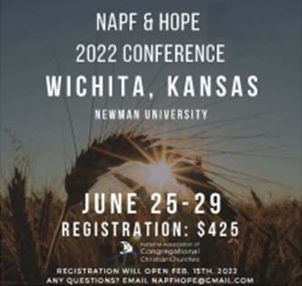
- The NAPF and HOPE 2022 Conference will be in Wichta, Kansas at Newman University on June 25-29. Registration fee is $425 and s now open! Any questions, email napfhope@gmail.com.
- The Michigan Congregational Summer Camp will be for 3rd–8th graders. It will be July 10-15th at the YMCA Camp Ohiyesa in Holly, MI. Camper Registration packets are now available at: www.michigancongregationalsummercamp.org.
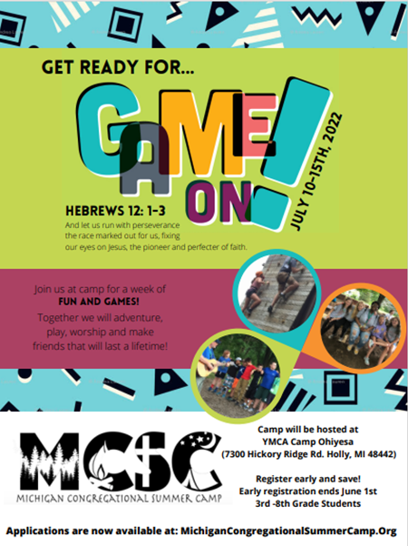
- Contact Claude Johnson if you would like more info on joining the youth group or upcoming missions, at claudej2002us@yahoo.com.
Message for Scouts
FCCoG thanks the Scouts for spreading mulch around the entire church! We appreciate all your hard work!
~ June 2022 ~
Sun | Mon | Tue | Wed | Thu |  | Fri | Sat
 |  |  | 1  10a PURLS  Preschool Bike Rodeo |  | 2  11a GAMA  4:30 Scouts (all)  7:30 AA | 3 | 4
5 Communion  Sunday  10:30 Worship  Special Music –  Julie Momber  Preschool Graduation @1pm | 6  Picnic @ Ms. Candy’s Farm! | 7 | 8  10a PURLS |  | 9  4:30 Scouts (all)  7:30 AA | 10 | 11
12  10:30 Worship  Special Music –  TBA | 13  8:30 Buzy Bees  Flag Day | 14  6:30 Deacons | 15  8:30 Buzy Bees  10a PURLS |  | 16  4:30 Scouts (all)  7:30 AA | 17 | 18  1p VanMolsten Wedding
19  Father’s Day  10:30 Worship  Special Music –  Sandy Cote and Deb Dieckman | 20  8:30 Buzy Bees | 21 | 22  8:30 Buzy Bees  10a PURLS |  | 23  4:30 Scouts (all)  7:30 AA | 24 | 25  1:30p  Shirley Kalbfleisch Memorial
26  9:30 Choir Practice  10:30 Worship  Special Music –  Chancel Choir | 27  8:30 Buzy Bees  6:30 Trustees | 28 | 29  8:30 Buzy Bees  10a PURLS |  | Happy Summer Break to All!
Calendar Notes:

~ July 2022 ~
Sun | Mon | Tue | Wed | Thu | Fri | Sat
 |  |  |  |  | 1 | 2
3  Communion  10:30 Worship  Special Music –  Deb Dieckman  3p Venture Crew | 4  ~Office Closed~ | 5 | 6  8:30 Buzy Bees  10a PURLS | 7  11a GAMA  7:30 AA | 8 | 9
10  10:30 Worship  Special Music –  TBA | 11  8:30 Buzy Bees | 12 | 13  8:30 Buzy Bees  10a PURLS | 14  7:30 AA | 15  4a Danish Festival Breakfast | 16
17  10:30 Worship  Special Music –  Claude Johnson  3p Venture Crew | 18  8:30 Buzy Bees | 19 | 20  8:30 Buzy Bees  10a PURLS | 21  7:30 AA | 22 | 23
24  9:30 Choir Practice  10:30 Worship  Special Music –  Chancel Choir | 25  8:30 Buzy Bees  6:30p Trustees | 26 | 27  8:30 Buzy Bees  10a PURLS | 28  7:30 AA | 29 | 30
31  10:30 Worship  Special Music –  Morgan Venema | Happy Independence Day to All!
Calendar Notes:

