FCC PILGRIM PULSE
November 2022
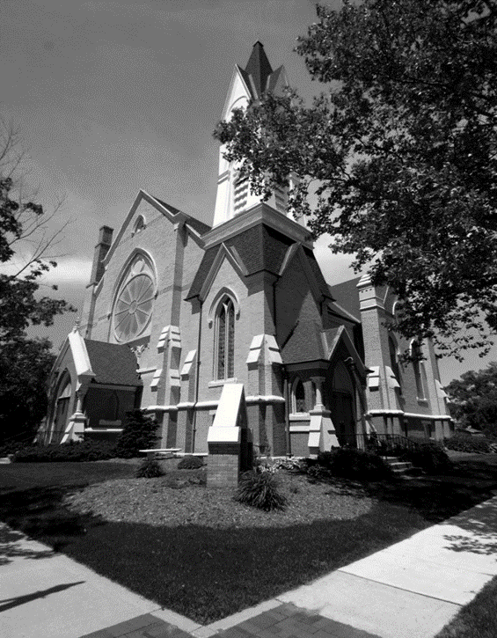

A Message from our Pastor…”Seeing God in Everyday Stuff”
When Natalie Sleeth wrote the song Praise the Lord with the Sound of Trumpet based on Psalm 150, she was able to capture the essence of seeing God in everyday stuff. The lyrics reflect the Psalmist’s heart that God can be seen and praised in everything that surrounds us. Here are lyrics to that wonderful and encouraging song.
“Praise the Lord with the sound of trumpet, praise the Lord with the harp and lute; praise the Lord with the gentle sounding flute. Praise the Lord in the field and forest, praise the Lord in the city square, praise the Lord anytime and anywhere. Praise the Lord in the wind and sunshine; praise the Lord in the dark of night; praise the Lord in the rain or snow or in the morning light. Praise the Lord in the deepest valley; praise the Lord on the highest hill; praise the Lord; never let your voice be still. Praise the Lord with crashing cymbal; praise the Lord with the pipe and string; praise the Lord with the joyful songs you sing. Praise the Lord on a weekday morning; praise the Lord on a Sunday noon; praise the Lord by the light of sun or moon. Praise the Lord in the time of sorrow, praise the Lord in the time of joy; praise the Lord every moment; nothing let your praise destroy. Praise the Lord in the peace and quiet, praise the Lord in your work or play; praise the Lord everywhere in every way!”
Sometimes in the business of life we all can find it hard to set aside time for meditation and silent reflection. It seems that most of the time we go from one activity to another and at the end of the day there remains a list of tasks that still remain undone. Well, if you are anything like me, those undone items end up on tomorrow’s list making tomorrow’s list that much more difficult to complete. Where am I going to find time for God during the course of my busy life? I believe we all agree that quiet time and times of silent relaxation are much needed, but we can also find time to pray and praise God in the mundane, boring, sometimes frustrating activities we are involved in. We seem to have much more time invested in the everyday comings and goings of life then we do in the area of spiritual renewal and reflection.
What if while we engage in the everyday duties we have in life, we find spiritual renewal and reflection? What if we could see and feel God’s presence in our lives in everyday stuff? That would be great. This will take a change of focus. Instead of trying to go to a special spot or set aside a certain time to meet with God, I am not saying that time is not important; we focus on God in the everyday moments of life. While we are getting our kids off to school, we see and praise God for the blessing of our children. While we are raking the leaves, we praise God’s for His wonderful creation. While we are driving from place to place, we praise God for the freedom we have in Christ. The list of opportunities is endless. If we begin to shift our focus to seeing God in our everyday stuff, our everyday stuff becomes the means in which we connect with God. By connecting with God on a regular basis throughout our day, I believe we will find that our days will become less stressful and our live will become more fulfilling.
I encourage you to give it a try. I pray that we will all get good at finding God in our everyday stuff and by doing that we can to find peace in our spirit and joy in our hearts. If you need a reminder of where look or a place to start looking for God in the everyday stuff; read the lyrics of the song above and go from there. God is all around us even in our everyday stuff. God bless you on your journey with Him.

Blessings in Christ,
Pastor Ed Milam

If you wish to have your name or your loved one to be placed on our prayer list, please contact the church office. *Please remember you must have permission to do so. Thank you!

IN OUR PRAYERS
OUR MILITARY: Matthew Crittenden, Jordan Varney, Paul Lepley, TJ Curry, Joshua Roose, Stephanie Roose, Melissa Staffen, Rick Grimes, Joe Suchowolec, Griffin Gloden, and Kyle Durdle.
Ongoing prayers for:
Lucas Hopkins  Rob Sansom  Larry Snow | Jerry McPherson  Gloria McPherson  Mary Ellen Rice | Dr. Joe & Valerie Mejia  Ken & Kathy Reed  James & Pauline Griffith | John Koppenol  Wilson & Barb Hoy  Carole Cole | Brian Tiffany  J.R. Withey  Tom Antor
FCC Family At Care Facilities:
Lois Hazelwood  Bette Houle  Corla Morgan  Barb & Wilson Hoy  Pat Toth  Doris Dieckman Marshall  Ray (Cap) Tower |  | -at Hathaway Hills Assisted Living Room #26  -at The Brook Assisted Living, Cedar Springs  -at SHUM RNC, Room #103  -at Canal View Houghton County Medical Facility  -at Hathaway Hills Assisted Living, Room #15  -at Boulder Creek Assisted Living  -at Hathaway Hills Assisted Living, Room #12
Special Prayers for Members, Family and Friends:
Virginia Case  Nic (recovering)  Dawn Dickinson (stage 4 cancer)  Ray (Cap) Tower  Stacy & Gavin  Jack & Ann Corner |  | Stepmother of Jim Case  Relative of Cindy Perry  Friend of Candy Outman  Husband of Janet Tower and FCC Member/Friend to all  Family of Darlene Petersen  FCC Members and friends to all
Congratulations to:
Samantha & Cecil Williams welcomed Zaniyah Amani Williams, born October 17th, 2022. This is the daughter of Kurt & Suzy Kreeger. Congratulations to the new grandparents! We praise God for this new wonder of life!
*Thank you to all for your Prayers! Please feel free to send a card to anyone listed above.

Pastoral Contact Info:
If you are in need of prayers or other assistance, please feel free to email Pastor Ed at pastor.edfccog@gmail.com.

Trustees of the Month: Jack Corner and Larry Snow
Deacon of the Month: Fran Gibbs
BOARD MEETINGS:
Deacons: Tuesday, Nov. 8th at 6:30pm
Trustees: Monday, Nov. 28th at 6:30pm

Pastoral News
Christian Education News
~ FCC News And Announcements ~
- New Members: On Sun. Nov. 20th, we will welcome Joshua & Emily Franklin and Tim & Stephanie Hyde to our FCCoG Family!
- Member Class: Please watch our bulletin and mailings for another class to be held after the new year! If you are interested in transferring your membership, contact Pastor Ed for more details on how to join our church!
- Ordination: Pastor Ed will be Ordained on Nov. 13th at 4pm. All are welcome to this momentous occasion! Dinner will be serviced after the service. We ask all guests who wish to attend the dinner, to please RSVP with the church office so we can plan for food! *To help serve or set up for the event, contact Chris Hubbard.
Church Office News
The church office hours are Mon. through Thurs. from 9:00-3:30 with a break from 2:00-2:30pm. Please call ahead if you need assistance.
- FCC Members and Guests: Please update your contact info (new address, email or phone number) to receive church mailings, with the church office. *You need not be a member to receive all the latest news and updates!
Celebrations
Happy Birthday! To Karen Hulbert (11/1), JJ Suchowolec (11/2), Cindy Perry (11/10), Chris Bosch (11/13), John House (11/24), Ann Corner (11/25), Stephanie Hyde (11/25), Lainey Emerson (11/26), Sandra Tiffany (11/26), and Dan Eagles (11/29). Happy Anniversary! To Brian & Lisa Gardner (11/2), Chris & Doug Dodd (11/24), Jack & Ann Corner (11/28), and Harry & Rose Riddle (11/29).
Parish Nurse News
Our Nurse is available Mon. and Tues. from 8-4, and Thurs. from 8-12. Call/text (616) 894-7288 for assistance.
- Medical Assistance: If you have medical questions, concerns, or need a ride, please call or text Patrice.
- Mental Health Emergency Number: call “988” for mental health crisis help.
- COVID Bivalent Vaccine is available now for ages 5 years old and up.
PF Youth News
Our next meetings are Nov. 6th and 20th after service. Church youth are encouraged to join us to plan for upcoming events and fellowship trips!
- Nov. 6th we will meet to discuss how we can help with the ordination for Pastor Ed on Nov. 13th!
- Join the PF Fall Youth Retreat on Sat., Nov. 6 from 10am to 5pm in Portland, MI. The theme “Shoot on Over” will be a day of games, songs, archery, road rally, lunch and snacks! All for the low price of $1! To register call the church office or contact Claude Johnson at claudej2002us@yahoo.com.
- Sunday School: Our Sunday School has seen some new faces and we love it! While we have enough teachers for every level, it would be great if we could have one or two more at the Grades 3-5 level. Other teachers can train you; Fran will go over the curriculum and have it prepared for you, and Sunday School is before church at 9:30am allowing plenty of time to also attend church. This change in schedule is working well. If you can spare a Sunday and would like to join this group of dedicated staff, please contact Fran at gibbsf7714@gmail.com.
- Children’s Sermon Presenters needed! Contact the church office to sign up.
- Sunday Morning Adult Bible Study: We have a growing group of participants that meet in Fellowship Hall (coffee provided). Please join them at 9:30am on Sundays. If you would like to join the study group, or for more information on the group, please contact Pastor Ed or the church office.
Music Committee News
Special Music Performances for November:
- Nov. 6: Ryan Mulcahy
- Nov. 13: Children’s Praise Choir
- Nov. 20: Claude Johnson
- Nov. 27: The Chancel Choir
- If you are of high school age or older and interested in singing with the Chancel Choir, contact Julie Momber, the office or come to a rehearsal. No auditions are necessary!
- Chancel Choir Rehearsal: is Nov. 20 at 9:15am and Nov. 27 at 9:30am, in the sanctuary.
Mutual Ministry Opportunities
We are always looking for ways for our congregation to be involved in our Sunday Service!
- Liturgist: If you would like to join our rotation of readers, please contact the church office. *If you are already on the rotation, no need to contact the office, unless you would like specific dates or would like to be taken off the list.
- Sound Techs: We are still looking for volunteers to learn our sound booth system and help with streaming our services. If interested, contact the church office (training is available).
Preschool News
Our children and families joined us Sunday at our Harvest Sunday Service and had much fun and fellowship!
- The children now planning the Thanksgiving feast that will take place on Mon., Nov. 21st.
- The children are also busy learning about the fall sesaon and the many reasons to be thankful this season!
Deacons
Children’s Praise Choir News
- Board Meeting: will be Tues., Nov. 8th at 6:30pm.
~ FCC News And Announcements (cont.) ~
- Ordination & Installation for Pastor Ed Milam! We have been working on the Ordination/Installation for Pastor Ed on Nov. 13th at 4pm. We need a count by Nov. 4 to have enough food and workers in place. We are partnering with Women’s Fellowship and certainly appreciate their leadership in hosting the dinner to follow. *Please note there will not be coffee service after church due to the Ordination and dinnerto follow.
- Coffee Service: Please consider signing up for Coffee Service. Thank you to those who have hosted multiple times so far. Please do not worry about making elaborate treats. The Deacons want this time to be enjoyable fellowship with the least amount of work.
- Nursery Service: We are using the Nursery again! There is a pack and play in the nursery, diapers and wipes, changing pad, and even a transponder that parents sign out and we can notify them of any problems in a discreet way. Marian Griffith, Patrice Fulton-Peacock, and Jane Truesdell have been helping serve our youngest.
- The Advent Season has been planned out to have two services on Christmas Eve, Sat., Dec. 24th with a Family Candlelight Service at 7pm and a Communion Candlelight Service at 11pm. With Christmas falling on a Sunday, the decision was made to have families watch a streaming of an uplifting message from Pastor Ed in the comfort of their homes, while enjoying family time! *Watch online at our Facebook page or YouTube Channel. The message will also be posted on our church Website.
- 2022 Advent Mission: Be sure to note the mission we have chosen for this year! The adult foster care home Rest Assured is newly opened in Gowen with a new owner, and they have many needs that are not covered by insurance or Medicaid/Medicare. There are 20 male and female residents in need! Collection begins Nov. 14 until Dec. 14. Here is a list of items to collect: blankets, pillows, heavy robes, warm footies/slippers, indoor “jackets”, lap blankets, prizes for bingo (dollar store finds), large print crosswords, word searches, mugs, reading glasses, hairbrushes, toothbrushes, candy of all kinds, pop, beef jerky, coloring books, crayons or color pencils, food, any or all non-perishable food, canned meats, vegetables, fruits, cereals, soups, hot chocolate mixes, even food gift cards would help, personal care items, shampoo, deodorant, lotion, toothpaste, shaving cream, razors, adult pull ups (not adult diapers). * If you cannot shop for items and wish to give cash, please consider sending a check to the church and the Deacons can shop for food. Thank you!
The group practices every Tues. evenings from 4-5pm and sings once a month at our Sunday Services. This group is for children ages pre-k through middle school. Please come join us one and all!
- Donations Needed: of individually wrapped snacks and/or juice for the group. Please drop off donations in the preschool or the front office marked “Praise Choir Snacks”. Thank you! To those of you who have donated to the group so far!
Women’s Fellwoship News
- Circle Meetings: Circles are meeting again, and we love it! Circles meet the first Wednesday of the month. Rosel Eagles is the contact person for Winslow Circle at 1pm at the church, and Fran Gibbs is the contact person for Bethany Circle that meets at 6:30pm in the library. Bethany will read “Sarah and Hagar” from the book ‘The Women of the Bible Speak.’ To get a book, contact Fran or feel free to get one on your own.
- HELPERS NEEDED: The Ordination/Installation Dinner is planned for Nov. 13th at 4pm, and workers are being recruited! If you would like to serve, please contact Chris Hubbard at 616-754-7464.
- Terri Lynn Nuts will be available for pickup on Mon., Nov. 14th.
- Fall Bake Sale and Famous Cookie Walk! Will be Nov. 19th. We need your fancy cookies, breads, pies, cakes, and other fancy baked goods. You can drop off goodies on Fri., the 18th between 10am and 4pm. The bake sale will run from 10am to 3pm. *Remaining cases of Terri Lynn Nuts and some other collections and items will be for sale by Women’s Fellowship.
- Board Meeting: will be Tues., Nov. 22nd immediately following the Hanging of the Greens.
- Hanging of the Greens is Nov. 22 at 10am Please join us to decorate the church for Advent. This is a fun time of fellowship and people of all skills are needed. We will have some refreshments, too!
Local Events and NEws
The Commision on Aging: For upcoming events, assistnace, or senior meals, call 989-831-7476 and select from the menu of options or visit: www.montcalmcountycommissiononaging.org.
Greenville Area Senior Citizens Center: Food with Friends Meals are served on Wed & thurs at noon. Call 616-894-2255 to reserve your lunch.
Greenville Community Center Theater Performance: Two of our church youth, Ellie Stek and Libby Suchowolec are starring in "Aladdin Junior" at the Community Center on Nov. 4th & 5th at 7pm, and at 2pm on Nov. 6th. Tickets are $10 in advance through the Community Center or $12 at the door.

Dear Brothers and Sisters in Christ,

The First Congregational Church of Greenville sends Christian Greetings to all of you!
The Great Head of the Church has united us in setting apart Charles Edward Milam for Christian Ministry through the solemn act of ordination.
We therefore invite you gather with us as we hold a Service of Ordination and Installation for C. Edward Milam as the Senior Pastor of the First Congregational Church of Greenville on Sunday, November 13th, 2022, at 4:00pm at the First Congregational Church of Greenville located at 126 E. Cass Street, Greenville, Michigan.
Dinner will be provided after the service. Please email the church office at office@fccogchurch.com or call the church at 616-754-3445 and let us know the number of people who will be attending, please RSVP by November 4, 2022, so that we may plan for food.
Wishing you grace, mercy, and peace.
We are fraternally yours,

Emily Suchowolec
Emily Suchowolec - Church Moderator
Patty Ritzema
Patty Ritzema - Church Clerk
Don Gibbs
Don Gibbs - Chairman of the Deacons
Christmas Poinsettias 2022
We invite you to place a poinsettia in the sanctuary in memory or in honor of a friend or loved one. The Deacons are offering you a convenient, affordable and mission-centered way to order your poinsettia through the church office. For the cost of $10.00 per plant, you can help support our Deacon’s Discretionary Fund and celebrate or remember a loved one. You may also choose to have your poinsettia delivered to someone on the friendship list.
Orders MUST be turned into the church office before Monday, December 5th. Simply fill out the order form below. You may pick up your poinsettia after the 11:00 PM service on Christmas Eve, or during the week of December 26th.

We are offering a 6” potted poinsettia. Please indicate below the number of plants and color(s) you would like to order along with who it is in Memory or in Honor of.
Name (please print): _______________________________________________
Mark #amount/number requested:
Red _____ White _____ Pink _____ Jingle Bells _____
# of plants ______ X $10.00 = $ ___________ total
*Please make checks payable to: First Congregational Church or FCCoG
In Memory of In Honor of: ______________________________________
In Memory of In Honor of: ______________________________________
In Memory of In Honor of: ______________________________________
In Memory of In Honor of: _____________________________________________
Yes, I would like to pick up my plant(s).
No, please deliver my plant(s) to someone on the prayer list.
*MAKE SURE TO TURN IN ORDERS
BEFORE MONDAY, DECEMBER 5TH!!!

~ November 2022 ~
Sun | Mon | Tue | Wed | Thu | Fri | Sat
 |  | 1  4p Praise Choir | 2  10a PURLS  1p Winslow  6:30 Bethany | 3  11a GAMA  4:30 Scouts (all)  7:30 AA | 4 | 5
6 Communion, Memorial Sunday, & Daylight Savings Ends  9:30 Sunday School  9:30 Bible Study  10:30 Worship  Special Music –  Ryan Mulcahy  3p Venture | 7  Preschool Picture Day! | 8  4p Praise Choir  6:30 Deacons | 9  10a PURLS | 10  Veteran’s Day  4:30 Scouts (all)  7:30 AA | 11 | 12  *10a PF Youth Retreat in Portland
13 Veterans  Sunday  9:30 Sunday School  9:30 Bible Study  10:30 Worship  Special Music –  Praise Choir  12p PF Mtg.  *4p Ordination Ceremony! | 14 | 15  4p Praise Choir | 16  10a PURLS | 17  4:30 Scouts (all)  7:30 AA | 18  *10-4 Bake Sale Goods  drop-off and set-up | 19  *10-3 Holiday Bake Sale
20 Heritage  Sunday  9:15 Choir Practice  9:30 Sunday School  9:30 Bible Study  10:30 Worship  *Welcome New Members!  Special Music –  Claude Johnson  3p Venture | 21  Preschoolers Thanksgiving Meal | 22  10a Hanging of the Greens  *WF Board Mtg. immediatley following | 23  10a PURLS | 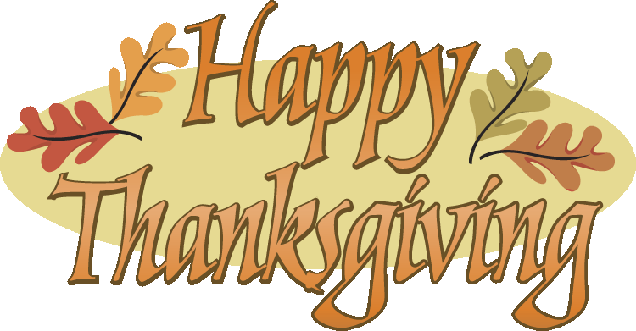  24  ~Office Closed~ | 25 | 26
27 1st Sunday  of Advent  9:30 Choir Practice  9:30 Sunday School  9:30 Bible Study  10:30 Worship  Special Music –  Chancel Choir  12p PF Mtg. | 28  6:30 Trustees | 29  4p Praise Choir | 30 | 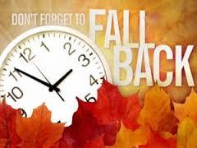
Calendar Notes:

~ December 2022 ~
Sun | Mon | Tue | Wed | Thu | Fri | Sat
 |  |  |  | 1  11a GAMA  4:30 Scouts (all)  7:30 AA | 2 | 3
4 Communion  9:30 Sunday School  9:30 Bible Study  10:30 Worship  Special Music –  TBA  3p Venture | 5  Christmas Poinsettia Orders DUE! | 6  Pearl Harbor  4p Praise Choir | 7  10a PURLS  1p Winslow  6:30 Bethany | 8  4:30 Scouts (all)  7:30 AA | 9 | 10
11  9:30 Sunday School  9:30 Bible Study  10:30 Worship  Special Music –  TBA | 12 | 13  4p Praise Choir  6:30 Deacons | 14  10a PURLS | 15  4:30 Scouts (all)  7:30 AA | 16 | 17
18  9:30 Sunday School  9:30 Bible Study  10:30 Worship  Special Music –  TBA  3p Venture | 19  6:30 Trustees | 20  4p Praise Choir | 21  10a PURLS  Christmas Break Dec. 21, 2022 to Jan 3, 2023 | 22  4:30 Scouts (all)  7:30 AA | 23 | 24  Christmas Eve  7p Servie  11p Service
25  NO SERVICE | 26 | 27 | 28  10a PURLS  Christmas Break Dec. 21, 2022 to Jan 3, 2023 | 29  4:30 Scouts (all)  7:30 AA | 30 | 31  New Year’s Eve
*Make sure to watch our Facebook and YouTube channel for a LIVE Christmas Message from Pastor Ed Milam at 10:30am on Sunday, December 25th!
Calendar Notes:

