FCC PILGRIM PULSE
October 2021
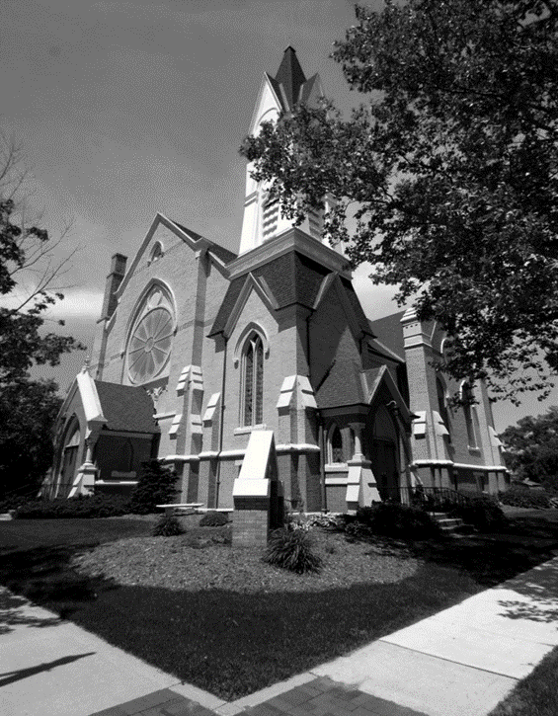

At First Congregational Church we believe all our members are ministers, called to serve God and our neighbors with the love and grace given to us through Christ Jesus.
We are a church that desires to love God and each individual made in God’s image. Whether you are grounded in your faith or still questioning your faith or somewhere in-between, we invite you to come as you are, and as you are able.
All are welcome.

If you wish to have your name or your loved one to be placed on our prayer list, please contact the church office. *Please remember you must have permission to do so. Thank you!
IN OUR PRAYERS
OUR MILITARY: Matthew Crittenden, Jordan Varney, Paul Lepley, TJ Curry, Joshua Roose,
Stephanie Roose, Melissa Staffen, Rick Grimes, Joe Suchowolec, Griffin Gloden, and Kyle Durdle.
Ongoing prayers for:
Lucas Hopkins  James Griffith, Jr.  Holly Case | Jerry Haverdink  Rob Sansom  Jerry Garner | Gloria McPherson  Kate Hanson  Jerry Kiste | Trudy Petersen  Theresa Loper  Kathy Cristofoli | Michele Kocher  Mar Newkirk  Chris Curtice
FCC Family At Care Facilities:
Lois Hazelwood  Bette Houle  Corla Morgan  Jelane Hamper  Polly Boatwright  Barb Hoy  Jackie Kocher  Mable Tate  Pat Toth |  | -at Hathaway Hills Assisted Living Room #31  -at The Brook Assisted Living, Cedar Springs  -at SHUM RNC, Room #103  -at Green Acres, Room #206  -at Green Acres, Room#204  -at Canal View Houghton County Medical Facility  -Homebound  -at United Rehab and Nursing, Room #108  -at Hathaway Hills Assisted Living, Room #15
Members, Family and Friends:
Peggy Milam  Joe Mejia |  | Mother of Ed Milam  Brother-in-law of Don & Julie Momber
Special Prayers For:
- Tanya Rectenwal (battling cancer)  - Brandt Wilson (battling cancer)  - Shirley Kalbfleisch (Kelsey Rehab Rm #220) |  | - Bonnie Braman & family for the passing of her brother, Bill Boyd.  - Shari Antcliff  - Brian Adair  - Deb Kazmierczak – daughter of Jerry & Marilyn Jones
Prayer Notes:

*Thank you to all for your Prayers! Please feel free to send a card to anyone listed above.
OFFICE HOURS: Monday thru Thursday from 9am to 3pm (break from 2:00-2:30).
The door is locked for staff safety. If you need assistance, please call ahead.
*Make sure to update your contact info with the church office to receive mailings on upcoming events!

Trustees of the Month: Jack Corner and Kirk Faber
Deacon of the Month: Emily Suchowolec
BOARD MEETINGS:
Deacons: Tuesday, Oct. 12th at 6:30pm
Trustees: Monday, Oct. 25th at 6:30pm

Pastoral Search Committee News
Children’s Praise Choir News
~ FCC News And Announcements ~
The Pastoral Search Committee would like to remind
everyone and invite you to attend our Holy Conversations with Pastor Case Van Kempen that begin this Sunday, Oct. 3rd at 6pm in Fellowship Hall. We hope to see you all there and ask that you plan to attend the evenings of October 10th and 17th at 6pm as well. Your input is critically important as we take a look at who we are, where we have been and where we are headed. Each Holy Conversation will last no more than 90 minutes and will include compiled information from the surveys we completed recently.
Rev.’s Wendy & Tom Van Tassell will be completing the Sermon Series on our Church Covenant on Oct. 17th. We then expect to have pulpit supply for one to two weeks as the Pastoral Search Committee completes its work.
Christian Ed News
We are looking forward to concluding the Intentional
Interim Process this month and are confident that God's hand is at work here at FCCoG. Thank you for your investment in this process - our future is bright! Please continue to pray with us the Prayer for Guidance.
Church Office News
Update to FCC Covid-19 Protocols
The church office hours are Mon. through Thurs. from 9-3 with lunch from 2:00-2:30pm. Please call ahead if you need assistance.
- Please update your contact information with the office so you don’t miss any updates and/or mailings!
- Many items have been found in the sanctuary over the year. If you are missing something, please contact the office.
FCC Celebrations
Happy Birthday! To Deb House (10/4), Diane Roose, (10/7), Lynn Wickerham (10/7), Jerry McPherson (10/21), Jim Ritzema (10/27), Roxy Rice (10/29), Mabel Tate (10/30), and Jeffrey Staffen (10/31). Happy Anniversary! To Rev. Jerry & Marilyn Jones (10/6).
Women’s Fellowship News
- Rummage Sale is Fri., Oct. 8 from 8-3 and we need helpers! Please contact Rosel if you can help with set up on Thurs. the 7th from 9-4 and/or the sale on Friday. Start your fall cleaning-out the closets and bring your items to the church beginning Mon., Oct. 4th.
- Prepaid pre-orders for Terri Lynn Nuts are due Oct. 7th! We will only have left over nuts and candy from partial cases ordered. *There is no extra ordering this year.
- Plan now for a Holiday Bake Sale in November! Rather than a full bazaar, we are hosting a Bake Sale on Sat., Nov. 20 with set up on Fri., Nov. 19. We hope to have the ever popular “Cookie Walk” so get out those fancy cookie recipes and feel free to donate other baked goods as well.
Practices are every Thursday from 4-5pm. We invite children of all ages to join us! *Contact Candy Outman or the church office to sign up or if you would like to donate snacks for the group.
Preschool News
Classes are going great and the kids were able to go on their first field trip to Anderson and Girls apple orchard; where we were able to get some treats and see all the new animals on the farm. Next month we will be learning about the fall season and will be carving pumpkins. October is also Fire Safety month, so we will have a visit form our local fire department. At the end of the month we will have our Halloween celebration with our annual trunk-or-treating in the parking lot!
Sunday School is open and running smoothly. The teachers are using new curriculum that is colorful and has many options. We are especially grateful that Ms. Candy can use the preschool & kindergarten lessons with her preschoolers, too! Children are excused after the children’s sermon to join their teachers in the classrooms. If you would like to do a Children's Sermon, please contact Fran Gibbs at 754-7714 or the office.
Mask-wearing will be required when entering the building. Once seated in the sanctuary for a meeting, you may remove your mask for the service, if you choose to do so. Then, when leaving the sanctuary and the building, please put the mask back on for the safety of everyone. For meetings in our church please sit as far apart as possible in rooms with ventilation. Mask should be worn by anyone that is not vaccinated. For the well-being of all, FCCoG will continue this masking protocol until Montcalm County goes to “moderate risk” transmission. *All are advised to social distance as much as possible while inside the building.
Parish Nurse News
COVID vaccine boosters are now available for anyone that is immunocompromised . If you are over 65, a front line worker, or have health issues and received the Pfizer vaccine 6 months or more ago you are eligible for a booster now. If you received a Moderna or J&J vaccine, those boosters should be available soon. Call 616-894-7288 with any questions.
Diaconate News
We meet Oct. 12 at 6:30. With the new mask request, we are holding off on coffee hour for now. However, Deacons will provide beverages for the three Holy Conversations on Oct. 3rd, 10th, & 17th. Thank you Joe Suchowolec for being the Deacon of the Month in September.
Member Spotlight (September)
Member Spotlight (September Cont.)
- Karen & Larry Carbonelli: The Carbonellis moved to Greenville in 1975 as Larry was managing The Daily News. The children, Cathy and Kevin, were in high school. Both were in sports so they made friends immediately. They also became involved in the youth group at FCC; the group was very active and they made many good friends. The family then transferred their membership from Ada Congregational Church to Greenville. Larry is now retired and Karen is working with Greenridge Realty. Karen also serves on the board of trustees at Montcalm Community College. They are avid University of Michigan football fans and attend all the home games. *Karen was recently awarded the Stanley and Blanche Ash Distinguished Service Award!
- Don & Fran Gibbs: They were married at FCC in 1972 by Henry Schadeberg, and Edward Brigham from Don’s family Church. Fran is a lifelong member, having been baptized & confirmed, and is a third-generation member of the Church. Don joined with a letter of reference in 1975. They have 3 children, all who have been active members in the past. They are very involved in Church leadership, serving in various capacities.
- Carla Durdle: became a member in 2002 but had attended about 3 years prior to joining. Her husband passed away in 2016. She has two sons, Chad and Scott. Chad (wife Tracy) live in Greenville where he works as a mechanic at Tinney. Scott (wife Marianne) live in Carrollton, Virginia where Scott has served our Country for 30 years as a commander in the U.S. Navy. She has 8 grandchildren and 2 great-grandchildren. She volunteers for the Church at funeral luncheons, rummage sales, and fall bazaar and is the “Cheer” person for the Women’s Fellowship. She enjoys spending time with family & friends, reading, working in the yard, watching Hallmark Channel, and playing Cookie Jam on her phone (she is on level 4624!).
- Chris Hubbard: joined in 2002 with her late husband Russ, shortly thereafter joining the Sunday school program; teaching junior high, and now working with 3rd, 4th, & 5th grades. Growing up in the congregational church school programs and camps gave her some wonderful mentors. She joined our preschool program in 2011 after retiring from Greenville Printing Company and joined Women's Fellowship in 2008 (current serving as president). She enjoys many different types of crafts, horseback riding, bowling, and most recently the love for parasailing!!! Most of all her heart lives for her great-grandchildren and hoping they will know our Lord!
- Jack & Ann Corner: Ann was baptized at FCCoG in 1954 and joined in 1957. She & Jack were married in 1964 by Rev. Ford. Jack joined in 1971 when they moved back to Greenville from Traverse City. Jack & Ann were Middle School PF advisors for 7 years and both have continued to serve in leadership roles. Jack has served as a Deacon, Trustee, Moderator, Boy Scout chairman, and as the preschool’s “Grandpa Jack.” Ann has been a Sunday School teacher, Deacon, coffee hour leader, and a part of Bethany circle. They are proudly part of 5 generations who have belonged to this Church from Ann’s grandparents through the marriage of one of their sons and baptism of one of their granddaughters! They are blessed not only with two grown and married sons, (Bill and Chris), but also 10 grandchildren and 3 great-grandchildren. They have felt blessed to have FCC as a support over the years.
- Don & Julie Momber: Julie’s first experience with FCCoG involved an invitation by Arnie Staffen to be a soloist in a cantata he was directing in the late 1980’s. She has been singing in the choir ever since, as well as at weddings, funerals, and community events. She has been the Chancel Choir music secretary for over 15 years, coordinates the special music for part of the year, served 2 terms as trustee, helps others with landscaping around the church and plants the flower pots by the front doors every spring. Julie is the president of the Friends of the Flat River Community Library, organizing the used book sales and Friends Bookstore. For fun, Julie maintains several flower gardens at her home, rides bike, kayaks, does yoga and is addicted to pickleball! Don & Julie are both retired school principals with a combined career of 65 years in education. They have been married 48 years and have 2 sons and 4 grandchildren. As well as being a teacher, athletic director and principal, Don as coached basketball, football and baseball for youth ranging from 4-18 years. He is a Vietnam veteran, an avid golfer and enjoys construction projects.
MUSIC COMMITTEE NEWS
Here is our Special Music line-up for October:
- Oct. 3 – video performance by The BYU Men’s Chorus singing “You Raise Me Up”.
- Oct. 10 – is a performance by the Chancel Choir
- Oct. 17 – is a performance by the Chancel Choir
- Oct. 24 – is a performance by Julie Momber
- Oct. 31 – is a performance by the Praise Choir
- If you would like to perform your special talent, please contact Julie Momber or the church office.
- * If you would like to sing with the choir, please join us during our rehearsals at 9:30 on the Sundays that we sing. If you would like to provide special music when none of the choirs are singing, please contact Julie Momber, 616 754-4531

~ October 2021 ~
Sun | Mon | Tue | Wed | Thu | Fri | Sat
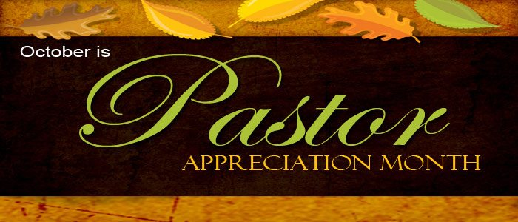 |  |  |  |  | 1 | 2
3 Communion &  Covenant Sermon Series  10:30 Worship  Guest Speaker  Rev. W. Van Tassell  Special Music  Julie Momber  3p Venture  6p Holy Mtg. | 4  *Bring in rummage sale items | 5  5:30 Girl Scouts | 6  10a PURLS  4p Girl Scouts | 7  *Set-up for Sale  9a to 4p  4p Praise Choir  4:30 Scouts (all)  7:30 AA | 8  WF Fall Rummage Sale!  8a to 3p | 9
10 Covenant  Sermon Series  9:30 Choir  10:30 Worship  Guest Speaker  Rev. W. Van Tassell  Special Music  Video Performance  6p Holy Mtg. | 11  Columbus Day | 12  5:30 Girl Scouts  6:30 Deacons | 13  10a PURLS  4p Girl Scouts | 14  4p Praise Choir  4:30 Scouts (all)  7:30 AA | 15 | 16
17 Covenant  Sermon Series  9:30 Choir  10:30 Worship  Guest Speaker  Rev. T. Van Tassell  Special Music  Chancel Choir  3p Venture  6p Holy Mtg. | 18 | 19  5:30 Girl Scouts | 20  10a PURLS  4p Girl Scouts | 21  4p Praise Choir  4:30 Scouts  7:30 AA | 22 | 23
24  9:30 Choir  10:30 Worship  Guest speaker  TBA  Special Music  Chancel Choir | 25  7p Trustees | 26  5:30 Girl Scouts  1p WF Board | 27  10a PURLS  4p Girl Scouts | 28  2p Preschool Trunk-or-treat  4p Praise Choir  4:30 Scouts (all)  7:30 AA | 29 | 30
31
10:30 Worship
Guest Speaker
TBA
Special Music
TBA
~ November 2021~
Sun | Mon | Tue | Wed | Thu | Fri | Sat
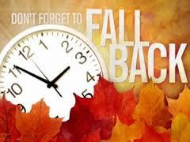 | 1 | 2  5:30 Girl Scouts | 3  10a PURLS  4p Girl Scouts | 4  4p Praise Choir  4:30 Scouts (all)  7:30 AA | 5 | 6
7 Communion & Daylight Savings Ends  10:30a Worship  Special Music  Preschoolers  3p Venture | 8 | 9  5:30 Girl Scouts  6:30 Deacons | 10  10a PURLS  4p Girl Scouts | 11  Veteran’s Day  4p Praise Choir  4:30 Scouts (all)  7:30 AA | 12 | 13
14 Veterans &  Rembrance Sunday  10:30a Worship  Special Music  Chancel Choir  3p Venture | 15 | 16  5:30 Girl Scouts | 17  10a PURLS  4p Girl Scouts | 18  4p Praise Choir  4:30 Scouts (all)  7:30 AA | 19 | 20
21  10:30a Worship  Special Music  Chancel Choir  3p Venture | 22  6:30 Trustees | 23  5:30 Girl Scouts  1p WF Board | 24  10a PURLS  4p Girl Scouts | 25  Office  Closed  Thanksgiving Break ~ Nov. 24-26 | 26 | 27
28  10:30a Worship  Special Music  Praise Choir  3p Venture | 29 | 30 | 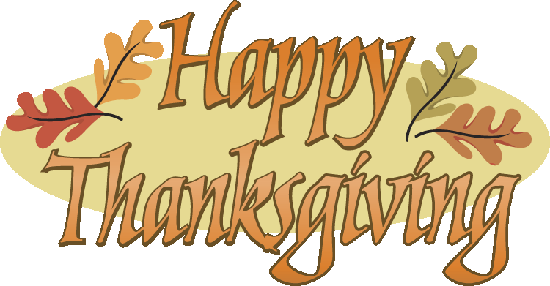
Calendar Notes:

