FCC PILGRIM PULSE
October 2022
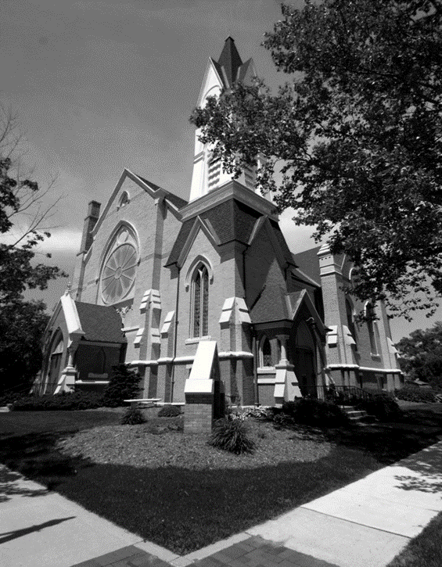

A Message from our Pastor…
Have you ever lost something valuable? It could be a special keepsake, a family photo or even your favorite baseball hat. Whatever it is, it needs to be found. We stop what we are doing because finding and retrieving the lost item just became priority number one. We will tear apart our cars, houses and offices to find these items. Our patience quickly wears thin if the search goes on for an extended period time. We become visibly upset when we lose something that holds a special place in our hearts. These special items will cause us to search for them with great passion and persistence.
Luke Chapter 15 verses 1-10 tells us the Parable of the Lost Sheep. We see here that Jesus puts a high priority in finding the lost sheep. Here is what is says, ¹“Now all the tax collectors and sinners were coming near to listen to him. ²And the Pharisees and the scribes were grumbling and saying, “This fellow welcomes sinners and eats with them.” ³So he told them this parable: ⁴“Which one of you, having a hundred sheep and losing one of them, does not leave the ninety-nine in the wilderness and go after the one that is lost until he finds it? ⁵And when he has found it, he lays it on his shoulders and rejoices. ⁶And when he comes home, he calls together his friends and neighbors, saying to them, ‘Rejoice with me, for I have found my lost sheep.’ ⁷Just so, I tell you, there will be more joy in heaven over one sinner who repents than over ninety-nine righteous persons who need no repentance.”
The owner of the 100 sheep could have been happy with just tending the 99 remaining sheep while accepting the loss of one sheep. After all, it is only one lost sheep. There would still be 99 sheep to manage and that is still good, right? It is tough to keep 100 sheep safe in the wilderness. Are we ok with losing one sheep to avoid the effort of searching for the lost one? Is it acceptable to only tend the sheep that are already safely together and leave the lost sheep to find its own way back? If the pattern of not looking for the lost one is repeated, the flock will slowly dwindle away. We are called by Jesus to look for the lost. This requires us to leave the comfort of our group and search in the wilderness for the lost one. The lost sheep Jesus are referring to those who have wandered away and not heard the life changing message of Jesus Christ.
Jesus commissioned his disciples to go and do this very thing. They were to go find the lost and share with them message of Jesus. Matthew 28:18-20 gives us the Great Commission. It states, ¹⁸“And Jesus came and said to them, “All authority in heaven and on earth has been given to me. ¹⁹Go therefore and make disciples of all nations, baptizing them in the name of the Father and of the Son and of the Holy Spirit ²⁰and teaching them to obey everything that I have commanded you. And remember, I am with you always, to the end of the age.”
If we will search for a lost hat or missing car keys with great passion and persistence, how much more passionate should we be with sharing the life-changing message of Jesus with the people we care about who are in the wilderness. We live life in this wilderness. I believe that if we share the gospel message of love, grace and hope through action, we can bring a positive change to our families and community. We cannot sit back safely in our groups and rest on the fact that we are ok when the world around us is suffering. Those lost in the wilderness needs to hear there is safety and security in Christ. It is our calling to go and do this work. May God bless us as we work to better our world through the power of Jesus Christ.

Blessings in Christ,
Pastor Ed Milam

If you wish to have your name or your loved one to be placed on our prayer list, please contact the church office. *Please remember you must have permission to do so. Thank you!

IN OUR PRAYERS
OUR MILITARY: Matthew Crittenden, Jordan Varney, Paul Lepley, TJ Curry, Joshua Roose, Stephanie Roose, Melissa Staffen, Rick Grimes, Joe Suchowolec, Griffin Gloden, and Kyle Durdle.
Ongoing prayers for:
Lucas Hopkins  Rob Sansom  Trudy Petersen | Jerry McPherson  Gloria McPherson  Natalie Wallace | Dr. Joe & Valerie Mejia  Ken & Kathy Reed  Virginia Evans | John Koppenol  Jerry Haverdink  Wilson & Barb Hoy | James Griffith, Jr.  Brian Tiffany  J.R. Withey
FCC Family At Care Facilities:
Lois Hazelwood  Bette Houle  Corla Morgan  Barb & Wilson Hoy  Pat Toth  Doris Dieckman Marshall |  | -at Hathaway Hills Assisted Living Room #26  -at The Brook Assisted Living, Cedar Springs  -at SHUM RNC, Room #103  -at Canal View Houghton County Medical Facility  -at Hathaway Hills Assisted Living, Room #15  -at Green Acres, Apt. #207
Special Prayers for Members, Family and Friends:
Tom Antor (cancer treatments)  Pauline Griffith (seizures)  Mary Ellen Rice  Carole Cole (cancer)  Virginia Case  Nic (recovering) |  | Brother of Anita Putnam  Niece of Marian Griffith  Friend of Marian Griffith  Friend of Darlene Petersen  Stepmother of Jim Case  Relative of Cindy Perry
Special Prayers to:
- For the family of Mabel Tate as she passed away September 4th.
- For Suzy Kreeger and family; for the passing of her father, Robert “Bob” Hoseth on September 5th.
*Thank you to all for your Prayers! Please feel free to send a card to anyone listed above.

Pastoral Contact Info:
If you are in need of prayers or other assistance, please feel free to email Pastor Ed at pastor.edfccog@gmail.com.

Trustees of the Month: Jack Corner and Kirk Faber
Deacon of the Month: Emily Suchowolec
BOARD MEETINGS:
Deacons: Tuesday, Oct. 11th at 6:30pm
Trustees: Monday, Oct. 24th at 6:30pm

Pastoral News
Christian Education News
~ FCC News And Announcements ~
- New Member Confirmands: On Sun. Sept. 11th, we welcomed Rachael Milam, Gavin Outman, Benjamin Venema, and Morgan Venema, into our FCCoG Family!
- Member Class: Classes are every Sunday evening at 6:30pm. *Our final class will be held Oct. 9. Contact the church office or Pastor Ed to join the class or if you are interested in transferring your membership.
- Guest Speaker: Pastor Ed will be out of the office for a conference the weekend of Oct. 23rd. We will have a guest speaker, Stephanie Clark, to lead us service that day! Please join us on this special occasion!
Church Office News
The church office hours are Mon. through Thurs. from 9:00-3:30 with a break from 2:00-2:30pm. Please call ahead if you need assistance.
- FCC Members and Guests: Please update your contact info (new address, email or phone number) to receive any church mailings, with the church office. *You need not be a member to receive all the latest news and updates!
Celebrations
- Happy Birthday! To Deb House (10/4), Diane Roose (10/7), Lynn Wickerham (10/7), Virginia Evans (10/15), Jerry McPherson (10/21), Jim Ritzema (10/27), Roxy Rice (10/29), and Jeffrey Staffen (10/31).
- Happy Anniversary! To Rev. Jerry & Marilyn Jones (10/6) and Tim & Stephanie Hyde (10/21).
Parish Nurse News
Our Nurse is available Mon. and Tues. from 8-4, and Thurs. from 8-12. Call/text (616) 894-7288 for assistance.
- Flu Shot Clinic: will be Oct. 9th at 11:30-12:30. *Forms are available by church bulletin board.
- Medical Assistance: If you have medical questions, concerns, or need a ride, please call or text Patrice.
- Mental Health Emergency Number: call “988” for mental health crisis help.
- Free COVID test kits are available in the nurses office (limited supply). Please contact Patrice for a test kit.
- COVID Booster available for Omicron Bivalent are now available locally; for those 12 and up, two months after their last vaccine or 3 months after having COVID.
PF Youth News
Our next meetings are Oct. 2nd and 16th after service. Church youth are encouraged to join us to plan for upcoming events and fellowship trips!
- Join the PF Fall Youth Retreat on Sat., Nov. 6 from 10am to 5pm in Portland, MI. The theme “Shoot on Over” will be a day of games, songs, archery, road rally, lunch and snacks! All for the low price of $1! To register call the church office or contact Claude Johnson at claudej2002us@yahoo.com.
- Sunday School is enjoying their curriculum and we usually have children in every class. Two more teachers are needed in the grades 3-5 classes. The first and third Sundays need coverage. If you are interested, call Fran Gibbs. We have a strong set of substitutes for when you cannot teach, but it would be nice to have a full staff. We welcome Miss Mary back to the grades 1 & 2 class!
- Children’s Sermon Presenters needed! A Children’s Message should be no more than 3-4 minutes in length, and based on something that moves you or they can follow the lectionary for that day. Contact the church office to sign up.
- Sunday Morning Adult Bible Study is running smoothly. We have a nice group of participants that meet in Fellowship Hall (coffee provided). Please join them at 9:30am on Sundays. If you would like to join the study group, or for more information on the group, please contact Pastor Ed or the church office.
Music Committee News
Special Music Performances for October:
- Oct. 4: Julie Momber
- Oct. 9: Children’s Praise Choir
- Oct. 16: Keith & Jean Hudson
- Oct. 23: The Chancel Choir
- Oct. 30: FCC Preschoolers
- If you are of high school age or older and interested in singing with the Chancel Choir, contact Julie Momber, the office or come to a rehearsal. No auditions are necessary!
- Chancel Choir Rehearsal: is Oct. 16 at 9:15am and Oct. 23 at 9:30am, in the sanctuary.
Mutual Ministry Opportunities
We are always looking for ways for our congregation to be involved in our Sunday Service!
- Liturgist: If you would like to join our rotation of readers, please contact the church office. *If you are already on the rotation, no need to contact the office, unless you would like specific dates or would like to be taken off the list.
- Sound Techs: We are still looking for volunteers to learn our sound booth system and help with streaming our services. If interested, contact the church office (training is available).
Preschool News
Our enrollment is full for the fall! We are busy with school work and fun making new friends!
- The children are also busy practicing for Oct. 30th when they will sing at worship service.
- They will then celebrate trunk-or-treating on the 31st of Oct. out in the parking lot!
Deacons
Women’s Fellwoship News
- The Board of Deacons is meeting on Tues., Oct. 11 to plan for the formal ceremony of Ordination & Installation for Pastor Ed Milam. We are excited to host a service in the afternoon of Nov. 13 followed by a dinner in Fellowship Hall. The Deacons and Women’s Fellowship will plan the dinner. Please sign up by the office so we have plenty of food. This event will take many hands so please say, “YES!”, if you are asked to help!
~ FCC News And Announcements (cont.) ~
- Pastor Appreciation Month is October, and we will be celebrating with Pastor Ed & Jenny on Oct. 9. You are welcome to bring a card any time up to that day and drop it in the box in the library. What a great time to recognize the gifts that Pastor Ed & Jenny bring to our church!
- Coffee Service: sign up is going well. If everyone continues to sign up outside the office, there shouldn’t be any confusion as to what openings there are. Thank you to so many of you that take multiple turns with coffee service.
- The Nursery Service is being used and is going well. If you are interested in working a shift in the nursery, please see Pastor Ed. All volunteers will need to have a background check and be in good health the day they serve. The worship service is on speaker in the room so you can still be inspired! We have a transponder system that can notify parents if needed
- Come Gather Sunday was very well attended! We had 134 peope join us for this wonderful day! We were able to welcome 4 new confirmand members to our Faith Family, we welcomed back our Praise Choir, and all those who joined us for our Adult Bible Studay and Sunday School classes before service. And we ended the day with a fellowship gathering, for a church potluck luncheon. Thank you to everyone who helped make this day special!
- WMCCC Conference: Thank you to everyone who attended and to all our volunteers who helped set up and cook food or donate treats for the event! It was very well attended!
Children’s Praise Choir News
The group practices every Tues. evenings from 4-5pm. This group is for children ages pre-k through middle school. The group will also sing once a month at our Sunday Services. Please come join us one and all!
- We are aslo asking for donations of individually wrapped snacks and/or juice for the group. Please drop off donations in the preschool or the front office marked “Praise Choir Snacks”. Thank you!
- Board Meeting: will be Tues., Oct. 25. Feel free to attend these meetings to learn more and contribute new ideas to Women’s Fellowship.
- Terri Lynn Nut are available on a pre-order, pre-paid basis. Please get your orders in by Sun., Oct. 3. If you are unable to come to church, call the office to have a form emailed to and have someone drop it off.
- Holiday Bake Sale We are hosting a Holiday Bake Sale on Saturday, November 19 from 10:00am to 1:00pm, with drop off on Friday, November 18 from 10:00am to 4:00pm. The featured cookie walk will be back along with many other baked goods. Please start planning now on baking some treats for the bake sale!
- CIRCLE MEETINGS ARE BACK! Circles meet the first Wednesday of the month.We have two groups (circles) women can participate in. Winslow Circle will meet at the church Wed., Oct. 5 at 1pm (Call Rosel Eagles if you would like to attend their group). They often have a devotion and fellowship with each other. Bethany Circle meets Wed., Oct. 5 at 6:30pm. Call Fran Gibbs if you would like more information. This group has chosen a book study about Women of the Bible and they too, have fellowship and pray for others.
- Hanging of the Greens is scheduled for Nov. 22 at 10am when the church is decorated for the upcoming Advent Season. We ask anyone who can help to join us!
- Watch for more information in early December on a work bee to make Chrismons to hand out on Christmas Eve. Cindy Perry is helping with her great Cricut skills working up ideas. Help will be needed to tie on hangars, bag up Chrismons, and add Bible verses to the baggies in preparation to share with others
Local Events and NEws
Murder Mystery Fundraiser: at Frugthaven Farm on Sat. Oct. 29. Shows times 4pm & 7:30pm. Cost is $30/ticket. Dinner, Dessert, & a show! Go to garcctickets.ludus.com for tickets (no door ticket sales).
The Commision on Aging: For upcoming events call 989-831-7476 and select from the menu of options or visit: www.montcalmcountycommissiononaging.org.
- TAKE-OUT OR DINE IN SOUP & SALAD BAR: provided by CoA in Stanton. Please reserve your meal by Monday at noon at 989-831-7476, option #1. *Meals are every Tues. and Thurs. Seniors 60+ is a $3 donation, under 60 is $6.50 charge.
- Greenville Area Senior Citizens Center: Food with Friends Meals are served on Wed & thurs at noon. Call 616-894-2255 to reserve your lunch.
- Senior Day at Anderson & Girls Orchard: the CoA is hosting a day at the farm on Wed., Oct. 12 at 1pm for the cost of $8 per person (bring cash the day of). Please call to reserve your spot by calling the CoA, option 0 by Oct. 7th.

~ October 2022 ~
Sun | Mon | Tue | Wed | Thu | Fri | Sat
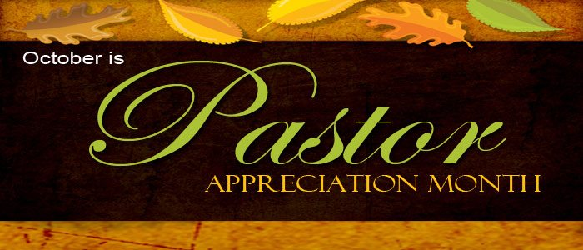 |  |  |  |  |  | 1
2 Communion  9:30 Sunday School  9:30 Bible Study  10:30 Worship  Special Music –  Julie Momber  11:45 Council Mtg.  11:45 PF Mtg.  3p Venture  6:30 Member Class | 3 | 4  4p Praise Choir | 5  10a PURLS  1p Winslow  6:30 Bethany | 6  11a GAMA  4:30 Scouts (all)  7:30 AA | 7 | 8
9  9:30 Sunday School  9:30 Bible Study  10:30 Worship  Special Music –  Praise Choir  11:30 Flu Shot Clinic  6:30 Member Class | 10  Columbus Day | 11  4p Praise Choir  6:30 Deacons | 12  10a PURLS | 13  4:30 Scouts (all)  7:30 AA | 14 | 15
16  9:15 Choir Practice  9:30 Sunday School  9:30 Bible Study  10:30 Worship  Special Music –  Keith & Jean Hudson  11:45 Pf Mtg.  3p Venture | 17 | 18  4p Praise Choir | 19  10a PURLS | 20  Pastor Ed gone for Conference  4:30 Scouts (all)  7:30 AA | 21 | 22  11a Versiti  Blood Drive  For Destini Cunliffe
23  9:30 Choir Practice  9:30 Sunday School  9:30 Bible Study  10:30 Worship  Guest Speaker –  Stephanie Clark  Special Music –  Chancel Choir | 24  6:30 Trustees | 25  1p WF Board  4p Praise Choir | 26  10a PURLS | 27  4:30 Scouts (all)  7:30 AA | 28 | 29
30  9:30 Sunday School  9:30 Bible Study  10:30 Worship  Special Music –  Preschoolers | 31  Preschool Trunk-or-treat
Calendar Notes:

~ November 2022 ~
Sun | Mon | Tue | Wed | Thu | Fri | Sat
 |  | 1  4p Praise Choir | 2  10a PURLS  1p Winslow  6:30 Bethany | 3  11a GAMA  4:30 Scouts (all)  7:30 AA | 4 | 5
6 Communion, Memorial Sunday, & Daylight Savings Ends  9:30 Sunday School  9:30 Bible Study  10:30 Worship  Special Music –  Ryan Mulcahy  3p Venture | 7  Preschool Picture Day! | 8  4p Praise Choir | 9  10a PURLS | 10  Veteran’s Day  4:30 Scouts (all)  7:30 AA | 11 | 12  *10a PF Youth Retreat in Portland
13 Veterans  Sunday  9:30 Sunday School  9:30 Bible Study  10:30 Worship  Special Music –  Praise Choir  11:45 PF Mtg.  4p Ordination Ceremony! | 14  Preschool Meal | 15  4p Praise Choir | 16  10a PURLS | 17  4:30 Scouts (all)  7:30 AA | 18  *Bake Sale Goods  drop-off and set-up | 19  *10-1 Holiday Bake Sale
20 Heritage  Sunday  9:15 Choir Practice  9:30 Sunday School  9:30 Bible Study  10:30 Worship  Special Music –  Claude Johnson  3p Venture | 21 | 22  10a Hanging of the Greens | 23  10a PURLS | 24  ~Office Closed~ | 25 | 26
27  9:30 Choir Practice  9:30 Sunday School  9:30 Bible Study  10:30 Worship  Special Music –  Chancel Choir  11:45 PF Mtg. | 28  6:30 Trustees | 29  4p Praise Choir | 30
Calendar Notes:

