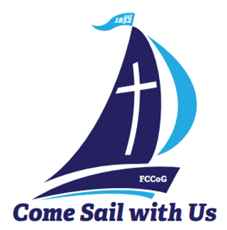
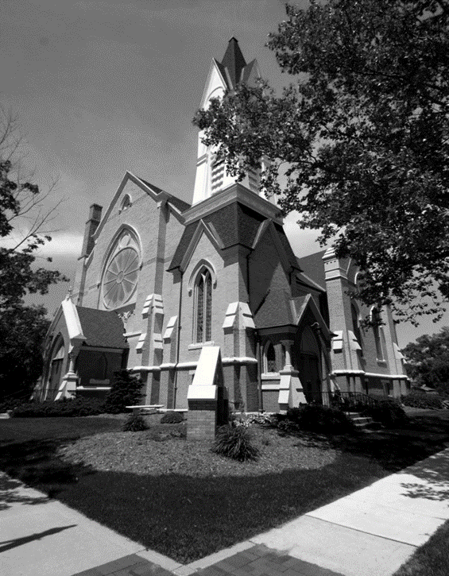
A Message from our Pastor…” Remembering Our Heritage”
August in Greenville means its Danish Festival time. As the celebration weekend gets closer, the history and heritage of our town and its people become frequent topics of conversation. People talk and reminisce about the great memories they have of growing up and living in the Greenville area. Where we came from and who are is something we should never forget. As we remember the positive lessons, memories, and experiences from our past, we are able connect with the legacies and passions of those who came before us. The First Congregational Church of Greenville has a 170-year history of ministry and service in the Greenville Area.
J.S Schenck writes in “History of Ionia and Montcalm Counties,” published in 1881, “On the 5th day of June 1852, a meeting was held in the public schoolhouse which stood on the corner of Cass and Lafayette Streets. It was called for the purpose of considering the expediency of organizing a Congregational Church.” In that meeting, it was decided by unanimous vote that the eleven founding members would become a Christian fellowship organized as the First Congregational Church of Greenville. This made the Congregational Church the second house of worship in Greenville. The Methodist church had organized a congregation in the years prior.
On June 6, 1880, over nine hundred people gather to dedicate the new church that was built to replace the original church structure that had become too small for the needs of the fellowship. This is the church we use today at the corner of Cass and Clay Streets. A newspaper article published shortly after the event stated, “This is the largest gathering ever collected under one roof in Montcalm County.” From that point on, the First Congregational Church has been a fixture in our downtown. I have spoken to several people around town who have a fond memory of times spent at this great church. It is the lessons we learned in scripture-based worship, Sunday school, Vacation Bible School and Youth Group that help guide how we live our lives.
The history and heritage of Greenville involves a special connection with our faith-based community. Since its beginning, the First Congregational Church of Greenville has focused of worshipping God, promoting Christian education, developing congregational fellowship, and serving the needs of the community. For generations, the connection with this church and the community has been impactful. Those connections still remain today. We love remembering our historical roots and what has brought us this far.
It is time to get back to our roots. It is time that we revive the priority of placing Christ at the center of all we do. Our schools, courts and public spaces used to be places where Christian principles were honored and respected. The society we live in has removed those guiding principles from use. Now more than ever, we need the influence of sound, Christian teaching, worship, and fellowship.
We can change our culture as we serve God together in all areas of our community. If we truly want peace in our world, we need Christ in it. Set sail with us on this journey! All are welcome!
Your brother in Christ – Pastor Ed.
FCC PILGRIM PULSE
October 2023

If you wish to have your name or your loved one to be placed on our prayer list, please contact the church office. *Please remember you must have permission to do so. Thank you!

IN OUR PRAYERS
OUR MILITARY: Matthew Crittenden, Jordan Varney, Paul Lepley, TJ Curry, Joshua Roose, Stephanie Roose, Melissa Staffen, Rick Grimes, Joe Suchowolec, Griffin Gloden, and Kyle Durdle.
Ongoing Prayers for:
Lucas Hopkins  Rob Sansom | Wilson & Barb Hoy  Rose Riddle | Dr. Joe & Valerie Mejia  Ken & Kathy Reed | Jerry McPherson  Holly Case | Trudy Petersen  Darlene Petersen
FCC Family At Care Facilities:
Bette Houle  Barb & Wilson Hoy  Pat Toth  Doris Dieckman Marshall  Cap (Ray) Tower |  | -at The Brook Assisted Living, Cedar Springs  -at Canal View Houghton County Medical Facility  -at Hathaway Hills Assisted Living, Room #15  -at Boulder Creek Assisted Living, Room #8  -at Hathaway Hills Assisted Living, Room #10
Continue Prayers for Members, Family and Friends:
Roxy Rice  Ken Reed |  | FCC Member and Friend to all  FCC Member and Friend to all
Special Prayers For:
- Alan Kingsbury (brother of Ron Kingsbury) for recovery and rehab.
- Friend of Anita Putnam (for lung transplant)
- The family of Lawrence Bisson, Jr. (Doug and Larry Bisson, brothers-in-law to Joe Suchowolec) for the loss of their father.
- Vincent Snow (1 month old) for upcoming testing; he is the great-grandson of Mary & Larry Snow
Special Event:
- Congratulations to: Parents Shayne & Anne Momber of Colorado Springs, CO. Who welcomed, Ames Christopher Momber, born on September 16. Ames joins sister Ada and brother Logan. Proud grandparents are Don and Julie Momber.
- Reminder for our Diaper Party for Emily & Josh Franklin on October 8th. Please see ‘Celebration News’ for more information!
*Thank you to all for your Prayers! Please feel free to send a card to anyone listed above.

Pastoral Contact Info:
If you are in need of prayers or other assistance, please call the office to make an appointment or email Pastor Ed at pastor.edfccog@gmail.com.

Trustees of the Month: Jack Corner and Larry Snow
Deacon of the Month: Tim Hyde
BOARD MEETINGS:
Deacons: Tues., Oct. 10th at 6:30pm.
Trustees: Mon., Oct. 23rd at 6:30pm.

Pastoral News
Restoration and Preservation for Our Church
~ FCC News And Announcements ~
- New Member Class will begin Sun., Oct. 1 from 12-1:30 for 4-weeks (with a light lunch provided). Please contact Pastor Ed for more info on becoming a member or if you would like more info on transferring your membership.
- Baptisms: for any member that would like to have their child or would themselves, like to be rebaptized to “refresh” your faith in the Holy Spirit, contact the office and we can schedule your baptism on an individual basis!
- Adult Bible Study meets every Sunday at 9:30am. Nursery service is available, and coffee will be available.
- Men’s Group: Pastor Ed invites all men of the church to join him for fellowship every Sat. at 9am. This group will be meeting for now book discussions and fellowship. Our first meeting will be a book discussion on Max Lucado’s “In the Grip of Grace.” Please see Pastor Ed to sign up or Don Gibbs to purchase a book.
Celebrations
- Happy Birthday! To Deb House (10/4), Diane Roose (10/7), Lynn Wickerham (10/7), Virginia Evans (10/15), Jerry McPherson (10/21), Jim Ritzema (10/27), Roxy Rice (10/29), and Jeffrey Staffen (10/31).
- Happy Anniversary! To Rev. Jerry & Marilyn Jones (10/6) and Tim & Stephanie Hyde (10/21).
- New Arrival coming soon…and it’s a GIRL! Please join us for a Diaper Party for Emily & Josh Franklin, Sun., Oct. 8th from 2-4pm in Fellowship Hall. Please bring a package of diapers (all sizes welcome) BUT…please no Huggies brand per request. In addition: any brand of wipes, bath supplies, Desitin diaper cream, and 0-3 month fall GIRL clothes are wonderful necessities this time for Emily & Josh! *Sign up is now complete for food. Thanks to all who signed up to help bring food for this special day!
PF Youth News
To join the group or for more info on upcoming PF Youth trips, call/text Claude Johnson at 616-894-5595 or email: claudej2002us@yahoo.com.
Chancel Choir News
Special Music Performances for October:
  - October 1: Julie Momber
  - October 8: Praise Choir
  - October 15: Chancel Choir
  - October 22: Chancel Choir
  - October 29: Deb Dieckman
  - Special Music Volunteers: If you would like to sing with the choir, or provide special
  - music, please contact Julie Momber or the church office.
  - Practices: the Chancel Choir will be rehearsing at 9:30am in the sanctuary on the 2nd, 3rd and 4th Sundays of the month, with performances on the 3rd and 4th Sundays. *Rehearsal on the first Sunday of the month will be scheduled as needed!
We wish to once again, thank all of you who have contributed to our church restoration and preservation project. Contributions received so far have kept pace with the expenses. If you are still interested in contributing to the restoration of our historic church building, please see the giving information below. All contributions are lovingly appreciated. Progress to date:
- The roof work is completed
- HVAC work is ongoing and nearing completion.
- The exterior brick repair is nearly done and is looking great. It will be sealed for lasting protection.
- Painting of all exterior trim will follow the brickwork.
- The rose window is partially restored. Additional work on the rose wind and work to the remaining windows, is scheduled for early spring 2024.
Again, thank you for your continued support. May God be with you and Bless you always. The Restoration and Preservation Project Committee
Scan our new QR code
or visit https://tithe.ly/give?c=6959110 to sign up to give today!
Church Office News
Office hours are Mon. – Thurs. from 9am to 3:30pm with a break from 2-2:30pm. Please call ahead for assistance or leave a message on the office phone.
- Contact Info: Please update your contact info (new address, email or phone number) to receive church mailings, with the church office. *You need not be a member to receive all the latest news and updates!
Parish Nurse News
Our Nurse is available Mon. and Tues. from 8-4, and Thurs. from 8-12. For medical questions or need a ride, please call/text Patrice at (616) 894-7288 for assistance.
- Blood pressure checks are offered prior to church on Sunday mornings. See Patrice in the church lobby.
- Flu Shot Clinic will be on Oct. 1st from 11:30 to 12:30. *Forms will be available soon.
- Free COVID tests & hand sanitizer is still available in the lobby!
Children’s Praise Choir News
We practice every Tuesday from 4-5pm. Children ages pre-k to 6th grade are welcome to join the group! Contact Candy Outman for more info.
- Donations of individually wrapped snacks or bags of candy, are needed. Please drop off donations to the preschool or church office. Thank you to those of you who have already donated snacks!
Deacons News
Women’s Fellowship News
- Next Meeting: will be Tues., Oct. 10th at 6:30pm. Please try to attend now that the busy season is upon us. Bring ideas for mission giving to start in November.
- Come Gather Sunday was very well attended! We had 174 peope join us for this wonderful day! We were welcomed back our Praise Choir, and thank all those who joined us for our Adult Bible Studay and Sunday School classes before service. As we ended the day with a fellowship gathering and church potluck, we want to thank everyone who helped make this day special!
- Volunteers: if you would like to give a children’s message and/or serve coffee, there are NEW sign up sheets by the church bulletin board. *Many dates are now available!
- Pastor Appreciation Month is Sun., Oct. 29th. We will be celebrating during the Church Potluck that is scheduled after service. This will be a great time to recognize the gifts that Pastor Ed bring to our church!
- Deacons are sponsoring a Halloween Potluck on Sun., Oct. 29 after worship. This is a family event with everyone bringing a dish to pass and table service. Fun events include games, decorating pumpkins, decorating cookies, and more. Anyone is welcome to wear a costume if it isn’t scary, bloody, or inappropriate! Come join the fun and watch our families enjoy the festivities as well.
Christian Ed News
- We have teachers but we are missing students! Sunday School at our church is fun! We have a short Bible lesson, crafts, games, and even a snack. We begin at 9:30am on Sundays and would love to have more students. While the kids are in Sunday School, consider attending Adult Bible Study or practice with the choir.
- Children’s Message: One treasured way of showing our families that we embrace them is to have a Children’s Message. If you have a personal story, or a message that you would like to share, please sign up outside the office. If you need help to come up with ideas, ask Fran Gibbs for sources. Please limit your message to no more than 4 minutes.
Preschool News
- This month we are having children bring in a letter themed item every week, learning fire safety, and learning how germs make us sick. We are also learning about the fall seasons, pumpkins, Halloween, and getting ready for our Trunk-or-treat event at the end of the month!
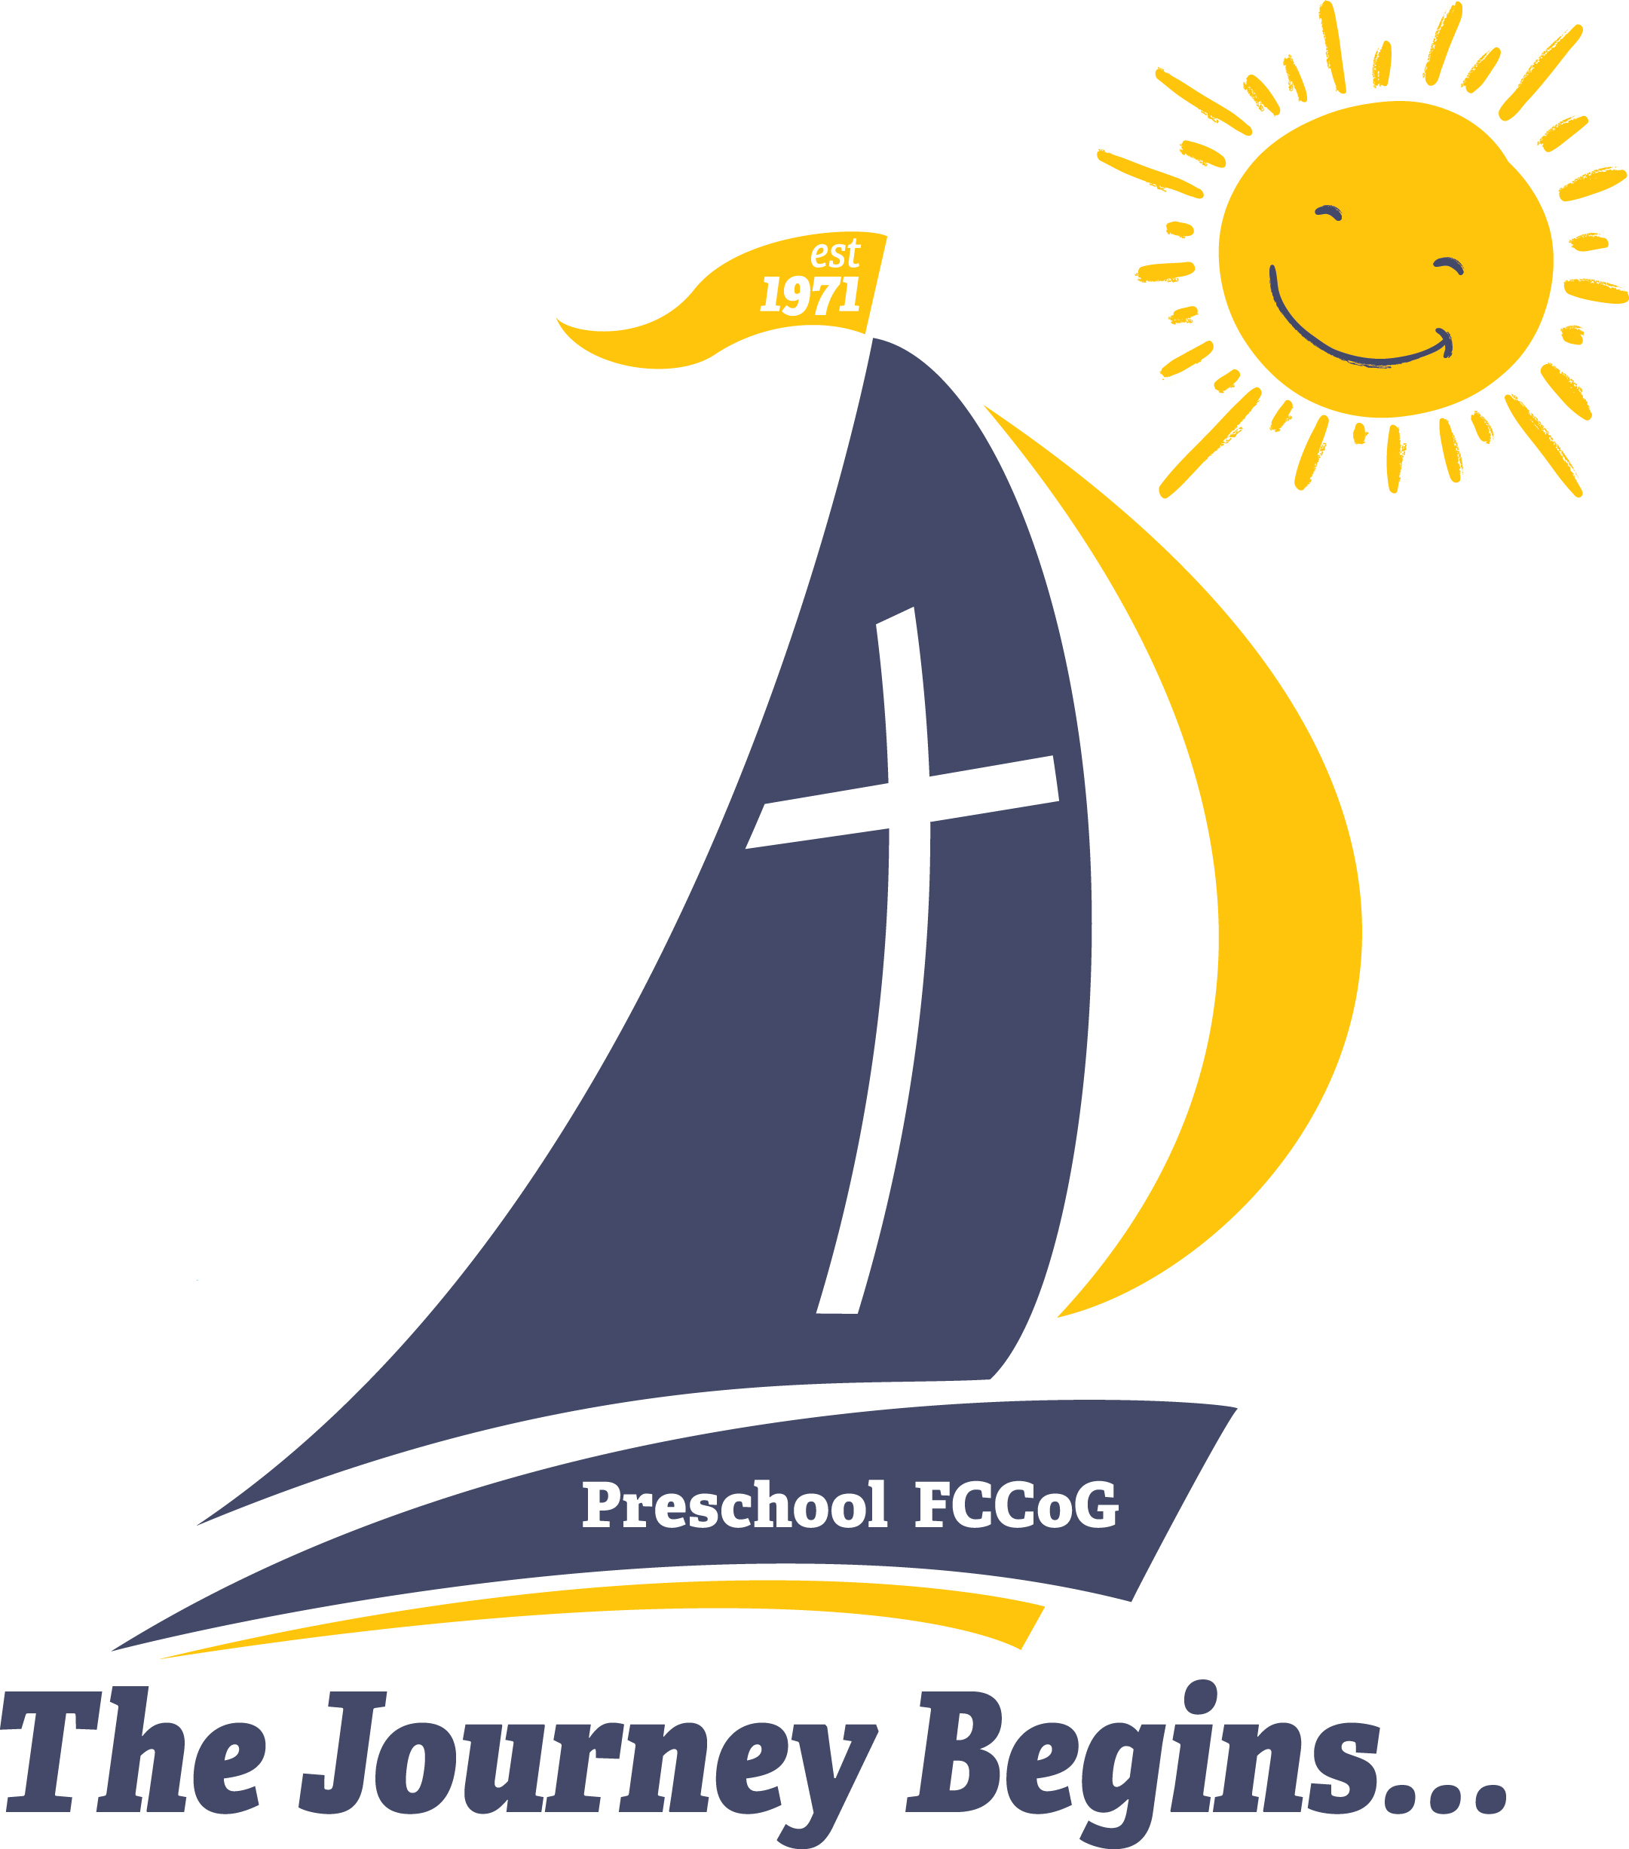
We still have some spots left in our program. If you or someone you know would like more information on our Christian based school, please contact the church office!

- Circle Members: the groups meet on Wed., Oct. 4. All women are invited to attend the time that works best for them. Winslow meets at 1pm and Bethany Circle meets at 6:30pm. Come and join in fellowship with these groups. For more information, contact the office and the Circle Chair will get back with you.
- Christmas Bazaar: Calling all bakers of any kind! Please plan to donate your baked goods and fancy cookies for the cookie walk. We will have vendors, a luncheon, and a great time!
  - Helpers Needed: There are many jobs for all committees like set up, luncheon, baked goods, kids’ crafts, etc. To have a successful event, YOUR help is needed! To help with this community event, sign up in the library, call Chris Hubbard, or contact the church office.
  - Crafters Needed: If you have high quality crafts and would like to rent a table, see Chris for a reservation form.
- Hanging of the Greens is scheduled for Nov. 28 at 10am when the church is decorated for the upcoming Advent Season. We ask anyone who can help to join us!
- Chrismons: we will be meeting on Dec. 9 at 1pm to make chrismons, to hand out on Christmas Eve.
Events in the Surronding Area
- Football Friends: Remember Come Gather Sunday? We had some members of the Freshman Football Team attend our church in support of Pastor Ed. How about supporting the team by attending a home game? Join us at 6pm for a game at GPS Stadium – only 2 games left! Admission is $5 per ticket. Thurs., Oct. 12 @4:30pm and Thurs., Oct. 19 at 4:30pm.
- The Flat River Community Players presents “Escanaba In Da Moonlight.” Show dates are Sept. 29 & 30 and Oct. 6 & 7 at 7:30pm. Tickets in Advance are $13 for adults and $11 for Seniors/Students. *At the door $15 for adults and $13 for Senoirs/Students. Visit gracctickets.ludus.com for more information.
- West Micnigan Women of Faith is hosting an event at the Greenville Community Center on Sat., Oct. 7 from 9am to noon. Friendships take on many forms. Join local women in a round-table setting to discuss friendships between Biblical figures, and how our own friendships can build our faith. Tickets are $20. Visit: www.garcctickets.ludus.com. *The group is also looking for any women who would like to lead a discussion table. For questions or to volunteer, contact wmwomenoffaith@gmail.com.
- Estate Planning Sarah Ostahowski from Sarah’s Law Firm will be at the CoA in Stanton, to answer questions about Estate planning. When: Thurs., Oct. 5 at 10am and Wed., Oct. 11 at 6pm. Call 989-831-7457 to reserve your spot. *Sign up by Oct. 2nd.

October 2023 ~
Sun | Mon | Tue | Wed | Thu | Fri | Sat
1 Communion  9:30 Sunday School  9:30 Bible Study  10:30 Worship  Special Music –  Julie Momber  11:30 Flu Shot Clinic  12p New Member Class Begins  3p Venture Crew | 2 | 3  4p Praise Choir | 4  10a PURLS  1p Winslow  6:30 Bethany | 5  11a GAMA  5p Scouts (Den)  7:30 AA | 6 | 7
8  9:30 Sunday School  9:30 Bible Study  10:30 Worship  Special Music –  Praise Choir  12p New Member Class #2  2p Franklin Diaper Party | 9  Columbus Day  No school GPS/Preschool | 10  4p Praise Choir  6:30 Deacons | 11  10a PURLS | 12  5p Scouts (Den)  7:30 AA | 13 | 14
15  9:30 Sunday School  9:30 Bible Study  10:30 Worship  Special Music –  Chancel Choir  12p New Member Class #3  3p Venture Crew | 16 | 17  4p Praise Choir | 18  10a PURLS | 19  5p Scouts (Den)  7:30 AA | 20 | 21  11-4 Cunliffe Blood Drive  6-8p Camp Greenwood Trunk-or-treat Event
22  9:30 Sunday School  9:30 Bible Study  10:30 Worship  Special Music –  Chancel Choir  12p New Member Class #4 | 23  6:30 Trustees | 24  4p Praise Choir | 25  10a PURLS | 26  5p Scouts (Pack Mtg)  7:30 AA | 27 | 28
29 Pastor  Appreciation Day!  9:30 Sunday School  9:30 Bible Study  10:30 Worship  Reception of New Members  Special Music –  Deb Dieckman  *Church Potluck* | 30 | 31  Preschool Trunk-or-treat | 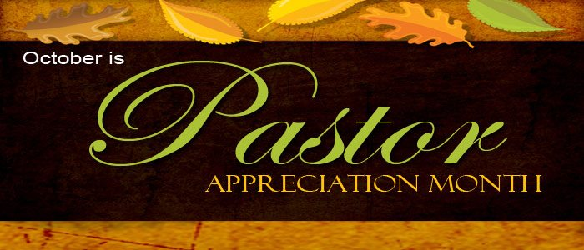
Calendar Notes:

~ November 2023 ~
Sun | Mon | Tue | Wed | Thu | Fri | Sat
 |  |  | 1  10a PURLS | 2  11a GAMA  5p Scouts (Den)  7:30 AA | 3 | 4
5 Communion & Daylight Savings Ends  9:30 Sunday School  9:30 Bible Study  10:30 Worship  Special Music –  TBA  3p Venture Crew | 6 | 7  4p Praise Choir | 8  10a PURLS | 9  5p Scouts (Den)  7:30 AA | 10  *Bazaar Vendors  set-up | 11  Veteran’s Day  9-3 Holiday Bazaar
12  Veterans Sunday  9:30 Sunday School  9:30 Bible Study  10:30 Worship  Special Music –  Praise Choir | 13 | 14  4p Praise Choir | 15  10a PURLS | 16  5p Scouts (Pack)  7:30 AA | 17 | 18
19  9:30 Sunday School  9:30 Bible Study  10:30 Worship  Special Music –  Chancel Choir  3p Venture Crew | 20 | 21  Preschool Meal (½ Day)  4p Praise Choir | 22  10a PURLS | 23  No School – Thanksgiving Break 22-24 | 24 | 25
26  9:30 Sunday School  9:30 Bible Study  10:30 Worship  Special Music –  Chancel Choir | 27  6:30 Trustees | 28  10a Hanging of the Greens  4p Praise Choir | 29 | 30
Calendar Notes:

