FCC PILGRIM PULSE
September 2022
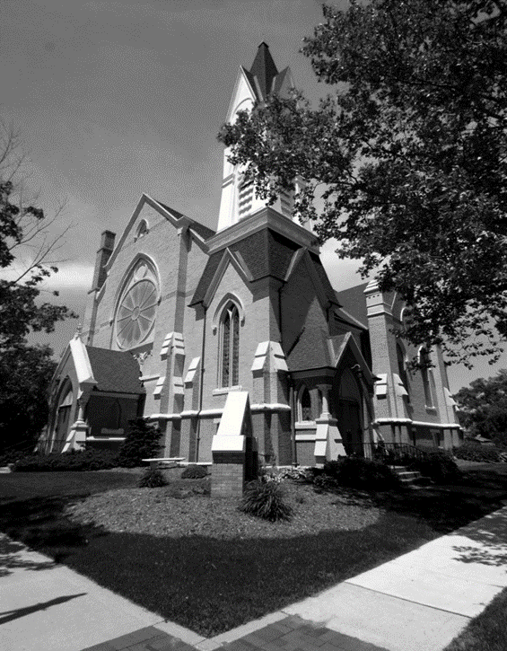

A Message from our Pastor…
August in Greenville means its Danish Festival time. As the celebration weekend gets closer, the history and heritage of our town and its people become frequent topics of conversation. People talk and reminisce about the great memories they have of growing up and living in the Greenville area. Where we came from and who are is something we should never forget. As we remember the positive lessons, memories and experiences from our past, we are able connect with the legacies and passions of those who came before us. The First Congregational Church of Greenville has a 170-year history of ministry and service in the Greenville Area.
J.S Schenck writes in “History of Ionia and Montcalm Counties”, published in 1881, “On the 5th day of June 1852, a meeting was held in the public schoolhouse which stood on the corner of Cass and Lafayette Streets. It was called for the purpose of considering the expediency of organizing a Congregational Church.” In that meeting, it was decided by unanimous vote that the eleven founding members would become a Christian fellowship organized as the First Congregational Church of Greenville. This made the Congregational Church the second house of worship in Greenville. The Methodist church had organized a congregation in the years prior.
On June 6, 1880, over 900 people gather to dedicate the new church that was built to replace the original church structure that had become too small for the needs of the fellowship. This is the church we use today at the corner of Cass and Clay Streets. A newspaper article publish shortly after the event stated, “This is the largest gathering ever collected under one roof in Montcalm County.” From that point on, the First Congregational Church has been a fixture in our downtown. I have spoken to several people around town who have a fond memory of times spent at this great church. It is the lessons we learned in scripture-based worship, Sunday school, Vacation Bible School and Youth Group that help guide how we live our lives.
The history and heritage of Greenville involves a special connection with our faith-based community. Since its beginning, the First Congregational Church of Greenville has focused of worshipping God, promoting Christian education, developing congregational fellowship, and serving the needs of the community. For generations, the connection with this church and the community has been impactful. Those connection still remain today. We love remembering our historical roots and what has brought us this far.
It is time to get back to our roots. It is time that we revive the priority of placing Christ at the center of all we do. Our schools, courts and public spaces used to be places where Christian principles were honored and respected. The society we live in has removed those guiding principles from use. Now more than ever, we need the influence of sound, Christian teaching, worship and fellowship.
On September 11th, the First Congregational Church of Greenville will be hosting our “Come Gather” Sunday Service. We will be launching our Sunday school program starting at 9:30am followed by the worship service at 10:30am. This is a great Sunday to gather for the first time with us or enjoy a homecoming visit to this grand, old church. It is time to get back to the basics of Christian living. We can change our culture as we serve God together into all areas of our community. If we truly want peace in our world, we need Christ in it. Set sail with us on this journey! All are welcome!

Blessings in Christ,
Pastor Ed Milam

If you wish to have your name or your loved one to be placed on our prayer list, please contact the church office. *Please remember you must have permission to do so. Thank you!

IN OUR PRAYERS
OUR MILITARY: Matthew Crittenden, Jordan Varney, Paul Lepley, TJ Curry, Joshua Roose, Stephanie Roose, Melissa Staffen, Rick Grimes, Joe Suchowolec, Griffin Gloden, and Kyle Durdle.
Ongoing prayers for:
Lucas Hopkins  Rob Sansom  Trudy Petersen  Candy Outman | Jerry McPherson  Gloria McPherson  Natalie Wallace  J.R. Withey | Dr. Joe & Valerie Mejia  Ken & Kathy Reed  Tom Antor | John Koppenol  Jerry Haverdink  Wilson & Barb Hoy  Tom & Dawn Deal | James Griffith, Jr.  Brian Tiffany
FCC Family At Care Facilities:
Lois Hazelwood  Bette Houle  Corla Morgan  Barb Hoy  Mable Tate  Pat Toth  Doris Dieckman Marshall  Wilson Hoy |  | -at Hathaway Hills Assisted Living Room #26  -at The Brook Assisted Living, Cedar Springs  -at SHUM RNC, Room #103  -at Canal View Houghton County Medical Facility  -at United Rehab and Nursing, Room #108  -at Hathaway Hills Assisted Living, Room #15  -at Green Acres, Apt. #207  -at Garden View Assisted Living, Calumet
Members, Family and Friends:
J.R. Withey  Larry Snow  Bette Houle  Virginia Evans (at United RNC room 101) |  | Son of Candy Outman  Member of FCC  Member of FCC  Member of FCC
Congratulations to:
Congratulations to Kayla and Kyle Gelow on the birth of their son Weston Mark Gelow born August 11, 2022. Grandparents are Mark and Trudy Petersen.
Message of Thanks:
- “I want to thank the congregation for all the prayers and encouragement that I received. Special thanks to Patrice, our parish nurse; she went over and above to help me and my grandson Gavin. She brought breakfast, drinks and anything I needed. We should all be thankful for the services she gives – she goes over and above making sure we were okay. Thank you Patrice – we really appreciate you! Ms. Candy & Gavin”
- “Dear Church Family: We hardly know where to start to thank you for all the kindness shown to us since Larry broke his hip. We thank you for all the love, prayers, cards, phone calls, delicious food, and offers to help. How blessed we are to have Pastor Ed and Jenny, and our awesome parish nurse, Patrice. Their hospital and homes visits and prayers have been so comforting to us. This is what Christian love is all about! ~Larry & Mary Snow”
*Thank you to all for your Prayers! Please feel free to send a card to anyone listed above.

Pastoral Contact Info:
If you are in need of prayers or other assistance, please feel free to email Pastor Ed at pastor.edfccog@gmail.com.

Trustees of the Month: Kurt Kreeger and Judy Swartz
Deacon of the Month: Joe Suchowolec
BOARD MEETINGS:
Deacons: Tuesday, Sept. 13th at 6:30pm
Trustees: Monday, Sept. 26th at 6:30pm

Pastoral News
Christian Education News
~ FCC News And Announcements ~
- Confirmands: Our Confirmands will be recognized September 11th at our “Come Gather” Sunday Service.
- Member Class: If you are interested in joining the church or transferring your membership, please see Pastor Ed for more details on how to join our church. We will begin new member classes on Sept. 18th at 6:30pm. This will be a four-week class. Contact the church office or Pastor Ed to register for the class.
- Wednesday night Bible Study: we are looking to hold a bible study on Wednesday’s nights for anyone interested. If you would like to have a mid-week study, please contact Pastor Ed to sign up!
Church Office News
The church office hours are now Mon. through Thurs. from 9:00-3:30 with a break from 2:00-2:30pm. Please call ahead if you need assistance.
- Please update your contact info (new address, email or phone number) to receive any church mailings, with the church office.
Celebrations
- Happy Birthday! To Ken Venema (9/4), Vivian Menard (9/9), Carol Magoon (9/12), Brianna Rowland (9/12), Trudi Cunningham (9/15), Myron Tiffany (9/15), John Emerson (9/19), Karen Skinner (9/19), Carolyn Foster (9/29), and Paul Jager (9/29).
- Happy Anniversary! To Larry & Karen Carbonelli (9/6), Jim & Holly Case (9/7), Don & Julie Momber (9/8), Kurt & Suzy Kreeger (9/15), Joshua & Emily Franklin (9/25).
Parish Nurse News
Deacons News
Our Nurse is available Mon. and Tues. from 8-4, and Thurs. from 8-12. Call/text (616) 894-7288 for assistance.
- Medical Assistance: If you have medical questions, concerns, or need a ride, please call/text Patrice.
- Mental Health Emergency Number: call “988” for mental health crisis help.
- Free COVID test kits are available to be mailed to your home by going to: accesscovidtest.org. If you need help with this contact Patrice. Test kits are also available in her office.
- Flu Shot Clinic: will be Oct. 9th at 11:30-12:30. *Forms are available by church bulletin board.
Preschool News
- Our enrollment is full for the fall! Ms. Candy, as well as our grandmas are excited to begin a new school year!. We will have some returning students and some new faces. Classes will begin Sept. 6th.
- Stop down to the preschool hallway to see the new upgrades to the preschool, as we have new cupboards in the class rooms and a fresh coat of paint in the hallway!

- Sunday School begins Sept. 11 at 9:30am! Patrice will be teaching Pres-k and Kindergarten; Fran will be teaching Grades 1 & 2; Terri will be teaching Grades 3-5, and Chris is teaching Grades 6-8. With Praise Choir singing that day, students will be dismissed early to practice or stay with your teacher, if you are not in choir, until 10:15. All classes are starting from the beginning of the Bible with lessons from Genesis!
- Children’s Sermon Presenters are needed starting Sept. 18th. A Children’s Message should be no more than 3-4 minutes in length, and based on something that moves you or they can follow the lectionary for that day. Contact Fran Gibbs 754-7714 to sign up.
Music Committee News
Special Music Performances for September:
- Sept. 4: Kathy Jeppesen.
- Sept. 11: Children’s Praise Choir
- Sept. 18: Larry Snow
- Sept. 25: The Chancel Choir.
- If you are of high school age or older and interested in singing with the Chancel Choir, contact Julie Momber, the office or come to a rehearsal. No auditions are necessary! Our next rehearsal is Sept. 18 at 9:15am in the sanctuary.
- We are still pursuing any interested people to direct choir. This is a paid position! See Fran Gibbs for more information.
- Our next meeting is Sept. 13th at 6:30pm.
- Coffee Service: There are still dates available for Sept. and Oct. *The sign-up sheet is by the church office/bulletin board.
- Come Gather Sunday is September 11! We have a busy day planned with Sunday School and Adult Bible Study starting at 9:30, Worship with special music from the Praise Choir, and Celebration of our Confirmation Class at 10:30am. A Church Potluck will be after worship with pulled pork and pulled chicken provided. Please bring a dish to pass and your own table service to this event.
- West Michigan Conference of Congregational Churches is Sat., Sept. 17. Thank you to all who are helping with food and hosting. All our church members are welcome to attend but we would like to know who might be coming. It starts at 9am and ends with lunch around 12:30. There will be a round table discussion on God’s Abundance, COVID, and its effects on churches. Please call the office at 754-3445 if you wish to attend or sign-up on the sheet by the church office.
Children’s Praise Choir
Practices are every Tues. evenings from 4-5pm. This group is for children pre-k through middle school. The group will also sing once a month at our Sunday Services (Dates TBA). Please come join us one and all!
~ FCC News And Announcements (cont.) ~
Mutual Ministry Opportunities
We are always looking for ways for our congregation to be involved in our Sunday Service!
• Liturgist: We are taking volunteers for the next rotation of anyone who would like to read at Sunday services. If you would like to help, please contact the church office. *If you are already on the rotation, no need to contact the office, unless you would like specific dates or would like to be taken off the list.
• Sound Techs: We are looking for volunteers to learn our sound booth system and help with streaming our services. If interested, contact the church office (training is available).
Women’s Fellowship News
- Board Meeting: will be Sept. 25 after church. Feel free to attend these meetings to learn more and contribute new ideas to Women’s Fellowship.
- Terri Lynn Nut sale! Forms for preorder/prepay will be available in early Sept. Please return your forms with payment no later than October 1st.
- Holiday Bazaar is scheduled for Sat., Nov. 19. More information will be provided closer to the date.
- Circle Leaders will be contacting current members and recruiting new members in Sept. Winslow Circle meets once a month at 1pm and Bethany Circle meets once a month at 6:30pm. Both groups welcome any women that would like to get to know others while having a devotion or book study, and a fellowship time with other women. Contact Rosel Eagles (754-8618) for Winslow Circle, and Fran Gibbs (754-7714) for Bethany Circle. You can also just come to the meetings starting in (tentatively) October. Watch for more information in your bulletins and newsletters.
- Hanging of the Greens is scheduled for Nov. 22 at 10am when the church is decorated for the upcoming Advent Season.
- The Board Meets next on Sept. 25 after church. Feel free to attend these meetings to learn more and contribute new ideas to Women’s Fellowship.
PF Youth News
- Kitchen Cleanup: Thank you to everyone who helped us with our kitchen clean-up and reorganizing the cupboards!
Update your Contact Information!
Please update your contact information to ensure you are receiving our general mailings, monthly newsletters, emails, and to add you to the list for birthdays and anniversarys. Please contact our office with any updates!
Contact Claude Johnson if you would like more info on joining the youth group or upcoming missions, at claudej2002us@yahoo.com.
- Our first PF Youth Meeting will be on Sept. 11th after our Church Potluck! We welcome our new Confirmands and any other youth, to join us!
Women of Faith Event
The West Michigan Women of Faith invites you to our second annual conference on Sept. 24th, for “Pieced Together through Faith”. We will spend a morning of worship, sharing, and small table study of the lives of selected women of the Old Testament. Come, add your voice to the conversation! Registration is at 8:30am. Worship and Conversation begins at 9am until 12pm. *Online registration will be available soon! For any questions, please contact the church office.
Church Renovations Continue!
We have recently replaced the carpet in the front lobby, painted down the preschool hall way and flooring back by the back kitchen door! Please make sure to stop by and see all the wonderful improvements being made! There will be more to come soon!
Local Events and NEws
The Commision on Aging is the Senior Newspaper for our county. For upcoming events and services, visit: www.montcalmcountycommissiononaging.org or call 989-831-7476 and select an option.
- PROJECT FRESH: this program provides coupons for fresh produce that can be purchased from locla farmers at farmers markets. Requirements are 60+, live in montcalm County, meet income guidelines (will be verified with you call). *Due to limited number of coupons available, you MUST call to regsiter at 989-831-7476, option #4.
- TAKE-OUT OR DINE IN SOUP & SALAD BAR: provided by CoA in Stanton. Please reserve your meal by Monday at noon at 989-831-7476, option #1. *Meals are every Tues. and Thurs. Seniors 60+ is a $3 donation, under 60 is $6.50 charge.
- Greenville Area Senior Citizens Center: Food with Friends Meals are served on Wed & thurs at noon. Call 616-894-2255 to reserve your lunch.
- Other events at the GR Senior Citizens Center: Tuesdays has Zumba at 9am, Senior Moment Café at 10:30am (3rd Tues. of month) , and euchre at 6pm. Wednesdays has penny bingo at 10am, food w/friends at 12pm. Thursdays has Quilting at 9am, Stamping class at 10am (1st Thurs. of the month), Food w/friends at 12pm, and cards at 1pm. Fridays has penny bingo at 12:30pm and cards at 1pm. For more information, call 616-754-1658.

~ September 2022 ~
Sun | Mon | Tue | Wed | Thu | Fri |  | Sat
 |  |  |  | 1  11a GAMA  4:30 Scouts (all)  7:30 AA | 2 |  | 3
4 Communion  10:30 Worship  Special Music –  Kathy Jeppesen  3p Venture Crew | 5  Labor Day  ~Office Closed~ | 6  First Day of Preschool | 7  10a PURLS | 8  4:30 Scouts (all)  7:30 AA | 9 |  | 10
11 Come Gather  Sunday!  9:30 Sunday School  9:30 Adult Bible Study  10:30 Worship  Welcome Confirmands  Special Music –  Praise Choir  Church Potluck  PF Youth Mtg. | 12 | 13  4p Praise Choir  6:30 Deacons | 14  10a PURLS  *Bible Study coming soon! | 15  4:30 Scouts (all)  7:30 AA | 16 |  | 17  9am WMCCC hosted here at FCCoG!
18  9:15 Choir Practice  9:30 Sunday School  9:30 Bible Study  10:30 Worship  Special Music –  Larry Snow  3p Venture | 19 | 20  4p Praise Choir | 21  10a PURLS | 22  4:30 Scouts (all)  7:30 AA | 23 |  | 24  8:30am Women of Faith Event
25  9:30 Sunday School  9:30 Bible Study  10:30 Worship  Special Music –  Chancel Choir  PF Youth Mtg.  WF Board Mtg. | 26  6:30 Trustees | 27  4p Praise Choir | 28  10a PURLS | 29  4:30 Scouts (all)  7:30 AA | 30
Calendar Notes:
*Look for Terri Lynn order forms to be available.

~ October 2022 ~
Sun | Mon | Tue | Wed | Thu | Fri | Sat
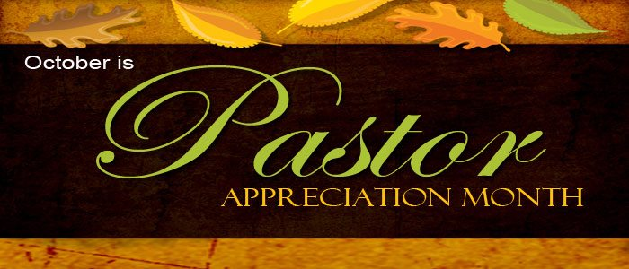 |  |  |  |  |  | 1
2 Communion  9:30 Sunday School  9:30 Bible Study  10:30 Worship  Special Music –  TBA  3p Venture | 3 | 4  4p Praise Choir | 5  10a PURLS | 6  11a GAMA  4:30 Scouts (all)  7:30 AA | 7 | 8
9  9:30 Sunday School  9:30 Bible Study  10:30 Worship  Special Music –  TBA  11:30 Flu Shot Clinic  PF Youth Mtg. | 10  Columbus Day | 11  4p Praise Choir  6:30 Deacons | 12  10a PURLS | 13  4:30 Scouts (all)  7:30 AA | 14 | 15
16  9:30 Sunday School  9:30 Bible Study  10:30 Worship  Special Music –  TBA  3p Venture | 17 | 18  4p Praise Choir | 19  10a PURLS | 20  4:30 Scouts (all)  7:30 AA | 21 | 22  Versiti  Memorial Blood Drive  For Destini Cunliffe
23  9:30 Sunday School  9:30 Bible Study  10:30 Worship  Special Music –  TBA  PF Youth Mtg. | 24  6:30 Trustees | 25  4p Praise Choir | 26  10a PURLS | 27  4:30 Scouts (all)  7:30 AA | 28 | 29
30  9:30 Sunday School  9:30 Bible Study  10:30 Worship  Special Music –  TBA | 31  Preschool Trunk-or-treat
Calendar Notes:

