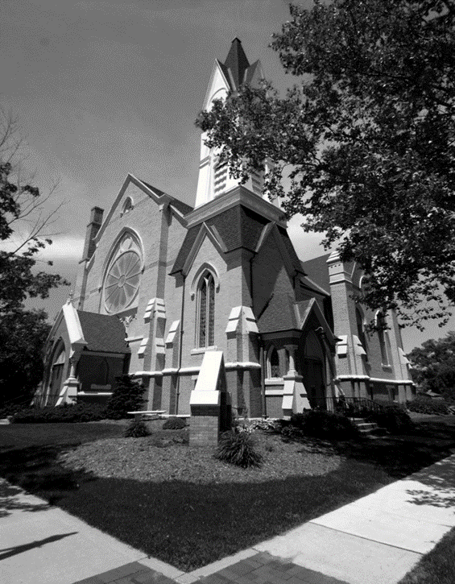
A Message from our Pastor…” Remembering Our Heritage”
August in Greenville means its Danish Festival time. As the celebration weekend gets closer, the history and heritage of our town and its people become frequent topics of conversation. People talk and reminisce about the great memories they have of growing up and living in the Greenville area. Where we came from and who are is something we should never forget. As we remember the positive lessons, memories, and experiences from our past, we are able connect with the legacies and passions of those who came before us. The First Congregational Church of Greenville has a 170-year history of ministry and service in the Greenville Area.
J.S Schenck writes in “History of Ionia and Montcalm Counties,” published in 1881, “On the 5th day of June 1852, a meeting was held in the public schoolhouse which stood on the corner of Cass and Lafayette Streets. It was called for the purpose of considering the expediency of organizing a Congregational Church.” In that meeting, it was decided by unanimous vote that the eleven founding members would become a Christian fellowship organized as the First Congregational Church of Greenville. This made the Congregational Church the second house of worship in Greenville. The Methodist church had organized a congregation in the years prior.
On June 6, 1880, over nine hundred people gather to dedicate the new church that was built to replace the original church structure that had become too small for the needs of the fellowship. This is the church we use today at the corner of Cass and Clay Streets. A newspaper article published shortly after the event stated, “This is the largest gathering ever collected under one roof in Montcalm County.” From that point on, the First Congregational Church has been a fixture in our downtown. I have spoken to several people around town who have a fond memory of times spent at this great church. It is the lessons we learned in scripture-based worship, Sunday school, Vacation Bible School and Youth Group that help guide how we live our lives.
The history and heritage of Greenville involves a special connection with our faith-based community. Since its beginning, the First Congregational Church of Greenville has focused of worshipping God, promoting Christian education, developing congregational fellowship, and serving the needs of the community. For generations, the connection with this church and the community has been impactful. Those connections still remain today. We love remembering our historical roots and what has brought us this far.
It is time to get back to our roots. It is time that we revive the priority of placing Christ at the center of all we do. Our schools, courts and public spaces used to be places where Christian principles were honored and respected. The society we live in has removed those guiding principles from use. Now more than ever, we need the influence of sound, Christian teaching, worship, and fellowship.
We can change our culture as we serve God together in all areas of our community. If we truly want peace in our world, we need Christ in it. Set sail with us on this journey! All are welcome!
Your brother in Christ – Pastor Ed.
FCC PILGRIM PULSE
September 2023

If you wish to have your name or your loved one to be placed on our prayer list, please contact the church office. *Please remember you must have permission to do so. Thank you!

IN OUR PRAYERS
OUR MILITARY: Matthew Crittenden, Jordan Varney, Paul Lepley, TJ Curry, Joshua Roose, Stephanie Roose, Melissa Staffen, Rick Grimes, Joe Suchowolec, Griffin Gloden, and Kyle Durdle.
Ongoing Prayers for:
Lucas Hopkins  Rob Sansom | Wilson & Barb Hoy  Rose Riddle | Dr. Joe & Valerie Mejia  Ken & Kathy Reed | Jerry McPherson  Holly Case | Trudy Petersen  Darlene Petersen
FCC Family At Care Facilities:
Bette Houle  Barb & Wilson Hoy  Pat Toth  Doris Dieckman Marshall  Cap (Ray) Tower |  | -at The Brook Assisted Living, Cedar Springs  -at Canal View Houghton County Medical Facility  -at Hathaway Hills Assisted Living, Room #15  -at Boulder Creek Assisted Living, Room #8  -at Hathaway Hills Assisted Living, Room #10
Continue Prayers for Members, Family and Friends:
Rob Sansom  Larry Alman  Roxy Rice |  | FCC Member and Friend to all  FCC Member and Friend to all  FCC Member and Friend to all
Special Prayers For:
- The Lafferty family for the loss of their son, Jamison (former preschool student).
- Prayers for the other boys involved in the accident that occurred back on Aug. 15; for recovery
- Alan Kingsbury (brother of Ron Kingsbury) for recovery and rehab.
- Friend of Anita Putnam (for lung transplant)
- Ken Reed (at Meijer Heart Center)
Special Event:
- There will be a Diaper Party for Emily & Josh Franklin on October 8th. Please see ‘Celebration News’ for more information!
*Thank you to all for your Prayers! Please feel free to send a card to anyone listed above.

Pastoral Contact Info:
If you are in need of prayers or other assistance, please feel free to email Pastor Ed at pastor.edfccog@gmail.com.

BOARD MEETINGS:
Deacons: Tues., Sept. 12th at 6:30pm.
Trustees: Mon., Sept. 25th at 6:30pm.
Trustees of the Month: Josh Franklin and Judy Swartz
Deacon of the Month: Emily Suchowolec

Pastoral News
Restoration and Preservation for Our Church
~ FCC News And Announcements ~
- New Member Class will begin Oct. 1 from 12-1:30 for a 4-week class. Please contact the church office or Pastor Ed for more info on becoming a member or would like more info on transferring your membership.
- Baptisms: for any member that would like to have their child or would themselves, like to be rebaptized to “refresh” your faith in the Holy Spirit, contact the office and we can schedule your baptism on an individual basis!
- Adult Bible Study begins on Sept. 10 at 9:30am. Nursery service is available, and coffee will be available.
- NEW Men’s Group: Beginning Sat., Sept. 16th at 9am, Pastor Ed invites all men of the church to join him for a new “Men’s Group”. This group will be meeting for book discussions and fellowship. Our first meeting will be a book discussion on Max Lucado’s “In the Grip of Grace.” Please see Pastor Ed to sign up or Don Gibbs to purchase a book.
‘Come Gather’ with us!
The Deacons invite you to attend church on Come Gather Sunday, on Sept. 10. This is a great time to renew your commitment to First Congregational Church! Launching that day is Sunday School and Adult Bible Study at 9:30, and Worship Service at 10:30 (free nursery provided). Then stay for a potluck after church with meat provided by the Deacons, and a Youth Group meeting for middle school and high school kids after the potluck in the upstairs conference room! Praise Choir will be singing during worship, to add to the enthusiasm of the day:
Sail into another great year with us!
Celebrations
- Happy Birthday to Ken Venema (9/4), Katie Suchowolec (9/5), Vivian Minard (9/9), Carol Magoon (9/12), Brianna Rowland (9/12), Trudi Cunningham (9/15), Myron Tiffany (9/15), John Emerson (9/19), Karen Skinner (9/19), Bonnie Wickerham (9/22), Carolyn Foster (9/29), and Paul Jager (9/29). Happy Anniversary! To Larry & Karen Carbonelli (9/6), Jim & Holly Case (9/7), Don & Julie Momber (9/8), Kurt & Suzy Kreeger (9/15), Joshua & Emily Franklin (9/25).
- New Arrival coming soon!!! Please join us for a Diaper Party for Emily & Josh Franklin, Sun., Oct. 8th from 2-4pm in Fellowship Hall. Please bring a package of diapers (all sizes welcome) BUT…please no Huggies brand per request. In addition: any brand of wipes, bath supplies, Desitin diaper cream, and 0-3 month fall GIRL clothes are wonderful necessities this time for Emily and Josh! *Please RSVP to Jenny Milam at 616-902-8768 (call/text) by Mon., Oct. 2nd.
PF Youth News
To join the group or for more info on upcoming PF Youth trips, call/text Claude Johnson at 616-894-5595 or email: claudej2002us@yahoo.com.
We wish to sincerely thank all of you who have contributed to our church restoration and preservation project. Contributions received so far have kept pace with the expenses. Much progress has been made toward completing this major undertaking. We are at the halfway point and have received nearly half the funds necessary to make this project a success. This project as a whole is estimated to cost over $250,000. Your generosity thus far is greatly appreciated. If you are still interested in contributing to the restoration of our historic church building, please see the giving information below. All contributions are lovingly appreciated. Progress to date:
- The roof work is completed
- Heating and air conditioning system (HVAC) is ongoing and nearing completion.
- The exterior brick repair is nearly done and is looking great. It will be sealed for lasting protection.
- Painting of all exterior trim will follow the brickwork.
- The rose window is partially restored; however we needed to acquire an additional company to work on the remaining windows. This will be scheduled for early spring 2024.
Again, thank you for your continued support. May God be with you and Bless you always. The Restoration and Preservation Project Committee
Scan our new QR code
or visit https://tithe.ly/give?c=6959110 to sign up to give today!
Church Office News
Office hours are Mon. – Thurs. from 9am to 3:30pm with a break from 2-2:30pm. Please call ahead for assistance or leave a message on the office phone.
- Contact Info: Please update your contact info (new address, email or phone number) to receive church mailings, with the church office. *You need not be a member to receive all the latest news and updates!
Parish Nurse News
Our Nurse is available Mon. and Tues. from 8-4, and Thurs. from 8-12. If you have medical questions, concerns, or need a ride, please call/text Patrice at (616) 894-7288 for assistance.
- Blood pressure checks are offered prior to church on Sunday mornings. See Patrice in the church lobby.
- Flu Shot Clinic will be on Oct. 1st from 11:30 to 12:30. Forms will be available soon.
- Free COVID tests are still available in the lobby!
- Free hand sanitizer is available in the lobby.
Children’s Praise Choir News
We practice every Tuesday from 4-5pm. Children ages pre-k to 6th grade are welcome to join the group! Contact Candy Outman for more info.
Chancel Choir News
Preschool News
Special Music Performances for Septmeber:
- September 3: Jamee Gun
- September 10: Praise Choir
- September 17: Chancel Choir
- September 24: Chancel Choir
- Special Music Volunteers: If you would like to sing with the choir, or provide special music, please contact Julie Momber or the church office.
- Practices: the Chancel Choir will be rehearsing at 9:30am in the sanctuary on the 2nd, 3rd and 4th Sundays of the month, with performances on the 3rd and 4th Sundays. *Rehearsal on the first Sunday of the month will be scheduled as needed!
Deacons News
- Meeting: will be Tues., Sept. 12th at 6:30pm.
- Over 100 people attended “Blessing of the Backpacks” in August! The kids brought their backpacks and received a blessing as well as teachers for the coming year. After Worship, children received a tag that said, “I am always with you” (Matt. 28:20) and assorted school supplies. This was the first year for this event that we hope to repeat every year.
- Thank you for signing up to host Coffee Service after worship and children’s messages. There are sign up sheets by the church bulletin board, if you would like to give a children’s message and/or serve coffee. *Many dates are available!
- Some of the deacons are sprucing up areas of the church to prepare for Preschool and Come Gather Sunday. Thank you “volunteers,” for all your help!
Christian Ed News
Sunday School BEGINS SEPT. 10 at 9:30am!
Come to the front lobby and we will direct you to the proper classroom.
- Our teachers are in the process of getting their background checks in place and curriculum is almost ready to go. We are inviting all kids to attend Sunday School if you are Preschool through Grade 5 this year. Most teachers will teach once a month and there are 2 openings left. If you are interested, please contact the church office or Fran Gibbs. All materials and a small snack are provided, and lessons are emailed to you the week you teach. We have substitutes and often the teachers trade among themselves.
- Children’s Message: One treasured way of showing our families that we embrace them is to have a Children’s Message. If you have a personal story, or a message that you would like to share, please sign up outside the office. If you need help to come up with ideas, ask Fran Gibbs for sources. Please limit your message to no more than 4 minutes.

- First Day of Class! Will be Tues., Sept. 5th. We are all so excited to start a new year! We have many new children joining the program this fall and joining our Prasie Choir as well!
- We still have some spots left, if you or someone you know would like more information on our fun & loving Christian based school, contact the church office! You can also download an enrollment packet by visiting our church website www.fistccog.org and clicking on the ‘Preschool’ tab.
Women’s Fellowship News
- Circle Members: will have their first meetings on Wed., Sept. 6th. Winslow will meet at 1pm and Bethany at 6:30pm. You don’t have to even reserve a spot. Come to the meeting and try it out! It might be a fellowship opportunity that is missing in your life. We meet the first Wednesday of each month, except January. If you would like more information on joining these groups, contact Rosel Eagles at 616-754-8618 (Winslow Circle) and Fran Gibbs at 616-754-7714 (Bethany Circle).
- Kitchen Clean Up ‘Thank you’! Thank you to all the helpers who came to help clean up our wonderful kitchen! Our kitchen looks amazing once again!
- Our first project was to do the annual “Cleaning of the Kitchen” on August 30 in preparation of Come Gather Sunday. We want to make it easier for Coffee Hour volunteers to find supplies and have all supplies in good order.
- Christmas Bazaar Returns! WF needs everyone to help to have a successful Bazaar this year! Mark your calendars for Sat., Nov. 11th from 9-3 (set up on Fri., Nov. 10 from 11-4).
- Here are some areas we need help with:
  - Looking for high-quality crafters interested in reserving a table for craft items,
  - volunteers to plan on baking fancy cookies and other baked goods,
  - help with the luncheon on both Friday and Saturday,
  - helpers to decorate on Fri., Nov. 10,
  - helpers to worke on Sat., Nov. 11.
- There will also be a kids’ craft table, a picture opportunity with Mr. and Mrs. Claus, the famous cookie walk, and the best lunch in town! To become a part of this wonderful event, contact Chris Hubbard (616-754-7464), Rosel Eagles (616-754-8618), or Fran Gibbs (616-754-7714) to volunteer today!

~ September 2023 ~
Come Gather Sunday!
September 10th
Sun | Mon | Tue | Wed | Thu | Fri |  | Sat
 |  |  |  |  | 1 |  | 2
3 Communion  10:30 Worship  Special Music –  Jamee Gun  3p Venture Crew | 4  Labor Day  Office Closed | 5  First Day of Preschool  4p Praise Choir | 6  10a PURLS  1p Winslow  6:30 Bethany | 7  5p Scouts (Den)  7:30 AA | 8 |  | 9
10 Come  Gather Sunday  9:30 Choir Practice  9:30 Bible Study and Sunday School Kick off!  10:30 Worship  Special Music –  Praise Choir | 11 | 12  4p Praise Choir  6:30 Deacons | 13  10a PURLS | 14  5p Scouts (Den)  7:30 AA | 15  McPherson Wedding Rehearsal |  | 16  9a Men’s Group meets  McPherson Wedding
17  9:30 Choir Practice  9:30 Sunday School  9:30 Bible Study  10:30 Worship  Special Music –  Chancel Choir  3p Venture Crew | 18 | 19  4p Praise Choir | 20  10a PURLS | 21  5p Scouts (Den)  7:30 AA | 22 |  | 23
24  9:30 Choir Practice  9:30 Sunday School  9:30 Bible Study  10:30 Worship  Special Music –  Chancel Choir | 25  6:30 Trustees | 26  4p Praise Choir | 27  10a PURLS | 28  5p Scouts (Pack Mtg)  7:30 AA | 29 | 30
Calendar Notes:

~ October 2023 ~
Sun | Mon | Tue | Wed | Thu | Fri | Sat
1 Communion  9:30 Sunday School  9:30 Bible Study  10:30 Worship  Special Music –  Julie Momber  11:30 Flu Shot Clinic  12p New Member Class  3p Venture | 2 | 3  4p Praise Choir | 4  10a PURLS  1p Winslow  6:30 Bethany | 5  11a GAMA  5p Scouts (Den)  7:30 AA | 6 | 7
8  9:30 Sunday School  9:30 Bible Study  10:30 Worship  Special Music –  Praise Choir  12p New Member Class  2p Franklin Diaper Party | 9  Columbus Day | 10  4p Praise Choir  6:30 Deacons | 11  10a PURLS | 12  5p Scouts (Den)  7:30 AA | 13 | 14
15  9:30 Sunday School  9:30 Bible Study  10:30 Worship  Special Music –  Chancel Choir  12p New Member Class  3p Venture | 16 | 17  4p Praise Choir | 18  10a PURLS | 19  5p Scouts (Den)  7:30 AA | 20 | 21  Michigan  Conference  in Grand Rapids
22  9:30 Sunday School  9:30 Bible Study  10:30 Worship  Special Music –  Chancel Choir  12p New Member Class | 23  6:30 Trustees | 24  4p Praise Choir | 25  10a PURLS | 26  5p Scouts (Pack Mtg)  7:30 AA | 27 | 28
29  9:30 Sunday School  9:30 Bible Study  10:30 Worship  Special Music –  TBA | 30 | 31  Preschool Trunk-or-treat | 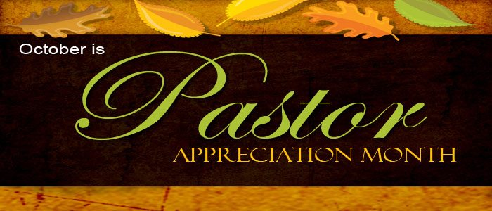
Calendar Notes:

