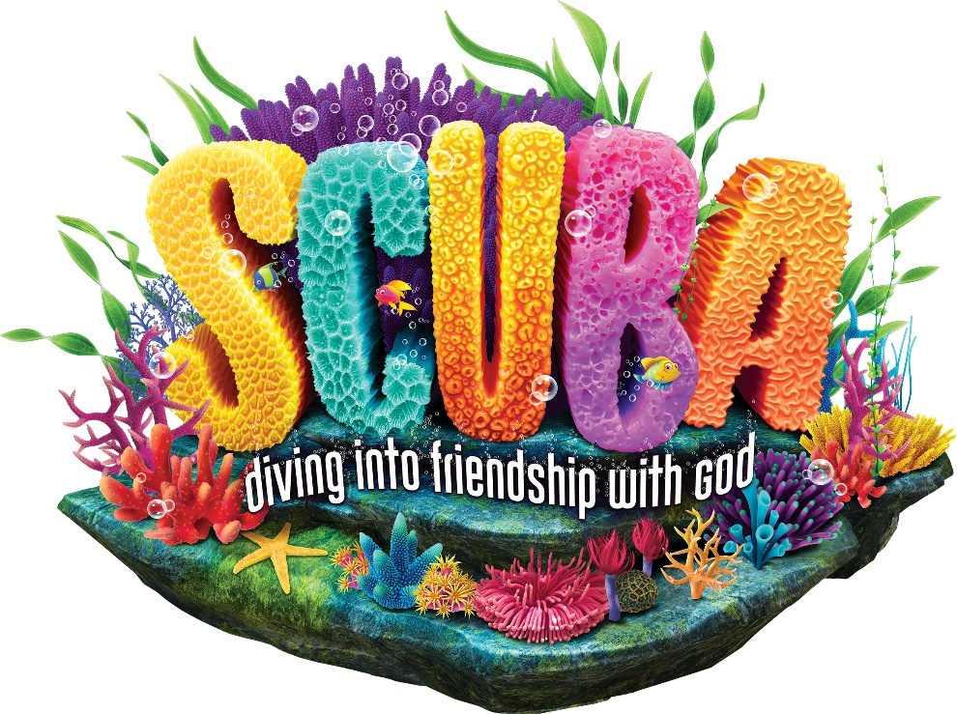
Join us for Vacation Bible School!
Where: First Congregational Church of Greenville
126 E. Cass Street ● (616) 754-3445 ● office@fccogchurch.com
When: Tues., June 11th to Fri., June 14th
Time: 9:30am to 12:00pm
Our theme is “SCUBA: diving into friendship with God!”
Visit https://vbspro.events/p/events/fccog24 or Scan the QR code to Register by June 9th!

Join us for Vacation Bible School!
Where: First Congregational Church of Greenville
126 E. Cass Street ● (616) 754-3445 ● office@fccogchurch.com
When: Tues., June 11th to Fri., June 14th
Time: 9:30am to 12:00pm
Our theme is “SCUBA: diving into friendship with God!”
Visit https://vbspro.events/p/events/fccog24 or Scan the QR code to Register by June 9th!

